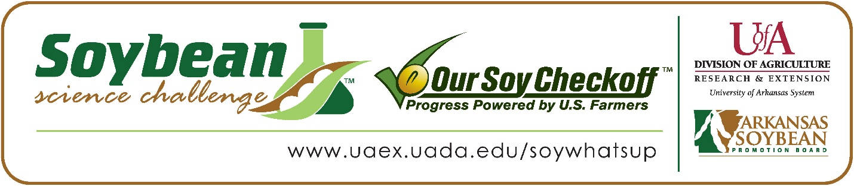

Kacylyn Reupta wins 2024 Arkansas Senior Division Soybean Science Challenge Award at the Ouachita Mountain Regional Science and Engineering Fair
Kacylyn Reupta, 14, a freshman at Genoa Central High School in Texarkana, Arkansas, won the Senior Division Soybean Science Challenge at the 2024 Ouachita Mountain Regional Science and Engineering Fair held in Hot Springs, March 1.
Reupta received a $300 cash award provided by the Arkansas Soybean Promotion Board. Her science project titled “Will different varieties of soybeans grow at the same rate?” also placed first in Plant Sciences.
Sheila Bentley, Reupta’s teacher, won the $200 Senior Division Soybean Science Challenge Teacher-Mentor Award. Bentley noted that the Soybean Science Challenge allows her students to work with projects that would be a benefit to their area. “I chose to have my students participate in the Soybean Science Challenge because I knew seeds were available that would provide a consistent test group. I also wanted to challenge my students to work toward a project that would benefit their environment and the community,” she replied.

Bentley also expounded upon what her students learned. “The four students who competed in the Soybean Challenge at the school level loved the knowledge they learned while researching and working on their Soybean Science Challenge projects. All the students said they knew very little about soybeans before beginning their projects. Each said they would like to learn more and compete in the Soybean Science Challenge again,” she said.
Kacylyn said winning the 2024 Soybean Science Challenge was quite an honor for her. “Becoming the 2024 Senior Division winner of the Soybean Science Challenge was a real honor. The cash prize will help me continue my project and pursue plans I have in mind to help other people,” she explained.
Mr. and Mrs. Ledbetter, Kacylyn’s parents, were thrilled about her award. “We were very proud of her as she worked very hard on her project. She was fascinated by how the sprouts sprouted and interested in which seed would sprout the best for her germination project. She loved working on her experiment procedure,” they replied.
The part of the Soybean Science Challenge course that appealed most to Kacylyn was learning about how important soybeans are. “What appealed most to me was the different families who had their own soybean farm. Their dedication to their farm and crops crossed many generations. These family farms that were passed down over time continued to thrive and improve, making their farms bigger and better,” she explained.
Sheila Bentley noted how she has learned more about soybeans through her students working on the SSC online course. “I learned that the Soybean Science Challenge offers many opportunities for student research that may apply to each student, from creating a marketable snack food product, testing the percent of chicken manure that produces the best soybean plant, to comparison of which seed type both germinates and shows the best growth in a controlled environment,” she related.

“The Soybean Science Challenge provides an opportunity for Arkansas junior high and high school students to participate in scientific research that can impact the State of Arkansas as well as the world. Soybean Science Challenge student researchers learn about this important commodity crop and its many uses including feeding the world, development of biofuels and sustainable products. The Soybean Science Challenge helps students develop an understanding of the challenges and complexities of modern farming,” said Dr. Julie Robinson, Associate Professor, and director of the program.
“The goal of the Arkansas Soybean Science Challenge is to engage students in “real- world” education to support soybean production and agricultural sustainability,” said Gary Sitzer, a former member of the Arkansas Soybean Promotion Board. “The program also rewards scientific inquiry and discovery that supports the Arkansas Soybean Industry.”
The Arkansas Soybean Science Challenge was launched in January 2014 to 9-12th grade science students. Students who successfully completed the online course were eligible to have their original soybean-related research projects judged at the 2024 ISEF-affiliated Arkansas Science and Engineering Fairs.
Information on the 2024-2025 Arkansas Soybean Science Challenge will be available in summer 2024. For more information, contact Dr. Julie Robinson at jrobinson@uada.edu, Diedre Young at dyoung@uada.edu or Keith Harris at kharris@uada.edu.
The Cooperative Extension Service is part of the University of Arkansas System Division of Agriculture.

Kacylyn Reupta, Albert J Murphy Junior High School, Texarkana, Arkansas; Teacher: Sheila Bentley
Category: Plant Sciences
Project Title: Will different varieties of soybeans grow at the same rate?

Abstract:
Purpose: Germinate three different types of soybean seeds, Tofu, Conventional, and Round-Up Ready using the same method to see if the three varieties of seeds would germinate and grow at the same rate.
Procedure: Place a row of 3 seeds and a column of 8 seeds totaling 24 seeds of each variety, Tofu, Conventional, and Round-Up Ready. Place the seeds into a sectioned glass container that will contain one variety of seed each. Spray the paper towel that covers the seeds entirely with water. Press down the dampened paper towel making it so that there are no air pockets in between the seeds. Put the lid on the container. Leave an air gap to allow oxygen to be present. Collect data every 2 days and have them all gathered in a week.
Results: Compare the three seeds: Tofu germinated the longest and fastest in the span of a week. Tofu seeds germinated twice as many seeds compared to the Round-Up Ready and 3 times as many as the Conventional seeds. Tofu seeds had longer sprouts, between 1cm and 5 cm each in length. Tofu seeds had healthier sprouts: All of the seeds that were used to experiment did not have any black spots on it, identifying the seeds to be spoiled.
Conclusion: Different varieties of soybean seeds displayed different germination results. Tofu variety met the germination conditions. Conventional and Round-Up Ready germinated less. The Tofu had a more successful germination rate. Tofu variety seeds germinated better under dark conditions and a high moisture level.

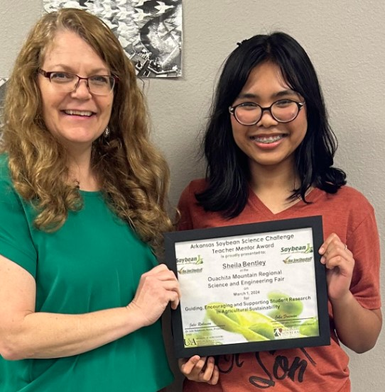
Ouachita Mountain Regional Science and Engineering Fair Senior Division Kacylyn Reupta and teacher-mentor Sheila Bentley

