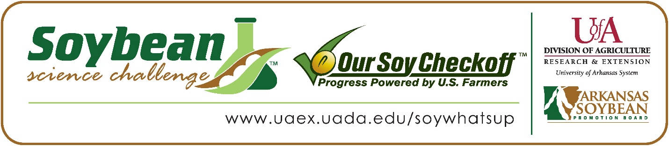
Hadley Panek wins 2024 Arkansas Soybean Science Challenge Junior Division Award at the Northwest Arkansas Regional Science Fair
Hadley Panek, 13, a 8th grader at St. Joseph Catholic School, won the Soybean Science Challenge Junior Division award at the 2024 Northwest Arkansas Regional Science Fair held at UofA Fayetteville on March 8.
Panek received a $200 cash award provided by the Arkansas Soybean Promotion Board. Her science project was titled “The effects of pretreatments on soybeans.”
Erin Wragg, Hadley’s teacher, won the $100 Soybean Science Challenge Junior Division Teacher-Mentor Award. Wragg stated that the Soybean Science Challenge is a great way to learn about agriculture today. “I asked those who were completing projects in Plant Sciences to consider using soybeans. The possible prize winnings incentivized my students. However, I feel that many students do not understand the impact that soybean production has on our state, and this program gave the students more insight as to why soybean research is important,” she replied.
Hadley was thrilled to win the 2024 Junior Division Soybean Science Challenge. “I was very excited to be chosen. Even though I put in a lot of hard work, I didn’t expect to win, especially with all the other amazing projects,” she stated.
The part of the Soybean Science Challenge Online Course Hadley liked the best was the credibility issues. “I really liked the written piece on what scientific articles tend to get published in the media and why. I thought it was interesting that the more popular an article is, the less reliable it tends to be,” she explained.
Wragg was thrilled to see Hadley win. “I was very excited for my student to win this challenge! I am also very happy to report that more students are discussing how to implement soybeans in their projects for next year now that they have witnessed their peer’s success,” she said.
“The Soybean Science Challenge provides an opportunity for Arkansas junior high and high school students to participate in scientific research that can impact the State of Arkansas as well as the world. Soybean Science Challenge student researchers learn about this important commodity crop and its many uses including feeding the world, development of biofuels and sustainable products. The Soybean Science Challenge helps students develop an understanding of the challenges and complexities of modern farming,” said Dr. Julie Robinson, Professor, and director of the program.
“The goal of the Arkansas Soybean Science Challenge is to engage students in “real- world” education to support soybean production and agricultural sustainability,” said Gary Sitzer, a former member of the Arkansas Soybean Promotion Board. “The program also rewards scientific inquiry and discovery that supports the Arkansas Soybean Industry.”
The Arkansas Soybean Science Challenge was launched in January 2014 to 9-12th grade science students and in 2021, added grades 6-8 for the Junior level award. Students who successfully completed the online course were eligible to have their original soybean-related research projects judged at the 2024 ISEF-affiliated Arkansas Science and Engineering Fairs.
Information on the 2024-2025 Arkansas Soybean Science Challenge will be available in summer 2023. For more information, contact Dr. Julie Robinson at jrobinson@uada.edu or Diedre Young at dyoung@uada.edu or Keith Harris at kharris@uada.edu.
The Cooperative Extension Service is part of the University of Arkansas System Division of Agriculture.
Hadley Panek, St. Joseph Catholic School, Fayetteville, Arkansas; Teacher, Erin Wragg
Category: Plant Sciences
Title: The effect of pretreatments on soybeans
Abstract:
The purpose of this project was to determine which different pretreatments worked best on soybeans. One hundred seeds were divided into five groups of pretreatments. Twenty seeds were given no pretreatment as the control group, twenty seeds were soaked in hot water for twenty minutes, twenty seeds were placed in cold water and refrigerated overnight, twenty seeds were soaked in sulfuric acid for seven minutes, and twenty seeds were placed in a jar with sandpaper covering it and shaken. The seeds were then planted in the same conditions and watered as needed. The number of soybeans sprouted and when they did was recorded. The seeds rubbed with sandpaper sprouted first, with control second, cold water third, hot water fourth, and sulfuric acid last. The conclusion was drawn that pretreating soybeans with sandpaper improves their growth rates, but cold water, hot water, and sulfuric acid slowed the growth rates.

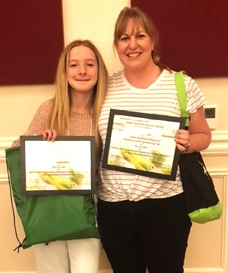

Northwest Arkansas Regional Science Fair Junior Division winner Hadley Panek, and Teacher-Mentor, Erin Wragg

