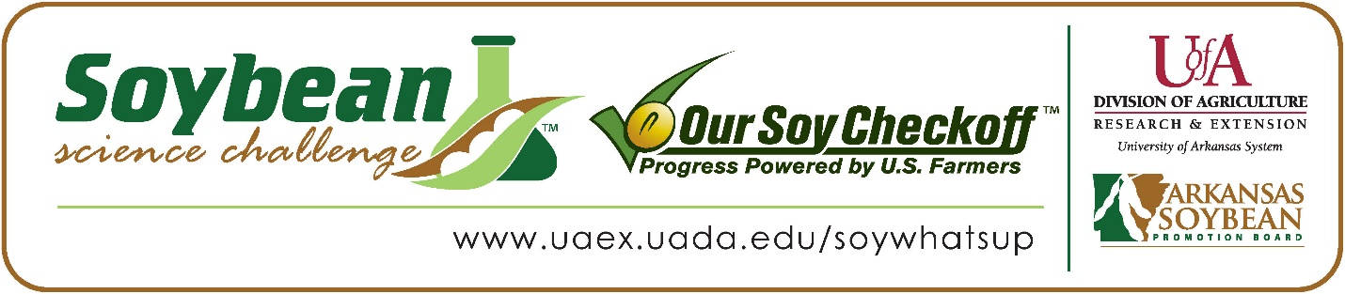
Aiden Watson wins 2024 Arkansas Soybean Science Challenge Junior Division Award at the Southwest Arkansas Emerson High School STEM Night
Aiden Watson age 14, an eighth grader at Emerson High School in Emerson, won the Soybean Science Challenge Junior Division award at the 2024 Southwest Arkansas Emerson High School STEM Night held at Emerson High School on April 18.
Watson received a $200 cash award provided by the Arkansas Soybean Promotion Board. His science project is titled “The effect of different soils on soybean plant growth.”
Jessi Glass, Watson’s teacher, won the $100 Soybean Science Challenge Junior Division Teacher-Mentor Award. Glass stated that the Soybean Science Challenge helps students to become familiar with agricultural research. “The Soybean Science Challenge is a great way to learn about the production of soybeans in Arkansas. The Challenge gives students the opportunity to carry out experiments and see what will help soybeans grow their best,” she replied.
Watson was excited to win the 2024 Junior Division Soybean Science Challenge. “I am very happy that the work and time I put into this is achieving things. I plan to compete in The Challenge again next year and try even harder,” he stated.
Amanda Watson, Aiden’s parent, was very proud to see him receive the award. “I am so glad Aiden’s work was recognized,” she responded.
Aiden was impressed at what he learned in the online course. “The most appealing part of the Soybean Science Challenge Online Course was how well run it was. The most interesting topic I found in the course was the detailed explanation of growth of soybeans. I enjoyed watching videos discussing their requirements to grow, and reading articles that gave greater detail into the growth process,” he said.
Glass explained that she benefited from Aiden’s participating in The Challenge this year. “I gained information about the growth of soybean plants in Arkansas. Thinking that most animal manure could be used as fertilizer and not knowing how nitrogen levels or pH levels in the manure affect the growth of the soybeans was a learning experience for both of us,” she replied.
“The Soybean Science Challenge provides an opportunity for Arkansas junior high and high School students to participate in scientific research that can impact the State of Arkansas as well as the world. Soybean Science Challenge student researchers learn about this important commodity crop and its many uses including feeding the world, development of biofuels and sustainable products. The Soybean Science Challenge helps students develop an understanding of the challenges and complexities of modern farming,” said Dr. Julie Robinson, Professor, and director of the program.
“The goal of the Arkansas Soybean Science Challenge is to engage students in “real- world” education to support soybean production and agricultural sustainability,” said Gary Sitzer, a former member of the Arkansas Soybean Promotion Board. “The program also rewards scientific inquiry and discovery that supports the Arkansas Soybean Industry.”
The Arkansas Soybean Science Challenge was launched in January 2014 to 9-12th grade science students. In 2021, the Junior Division award was added for grades 6-8. Students who successfully completed the online course were eligible to have their original soybean-related research projects judged at the 2024 ISEF-affiliated Arkansas Science and Engineering Fairs.
Information on the 2024-2025 Arkansas Soybean Science Challenge will be available in summer 2024. For more information, contact Dr. Julie Robinson at jrobinson@uada.edu or Diedre Young at dyoung@uada.edu or Keith Harris at kharris@uada.edu.
The Cooperative Extension Service is part of the University of Arkansas System Division of Agriculture.
Aiden Watson, Emerson High School, Emerson, Arkansas; Teacher, Jessica Glass
Category: Plant Sciences
Title: The effect of different soils on soybean growth
Abstract:

This experiment was designed to test what kind of soil has the largest effect on soybean plants growth. Eleven materials were used, including soybean seeds, potting soil, soil with pig manure, soil with chicken manure, soil with goat manure, containers for the soil, water, a ruler, and a notebook for data entry.
My research showed that the soybean seeds planted in the potting soil grew the best. The hypothesis that the soybean seeds planted in chicken manure would grow the best (due to high nitrogen content) was rejected.
This research provides people with information regarding the best soil for soybean growth. My goal to conduct thorough research and come to an evidence-based conclusion on the best soil for soybeans was successful.

