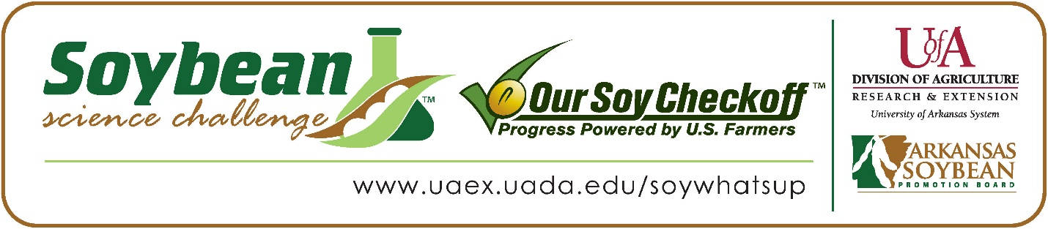
Sulli Schaffer wins 2024 Arkansas Soybean Science Challenge Honorable Mention Award at the Arkansas State Science and Engineering Fair
Sulli Schaffer, 16, a sophomore at Gravette High School in Gravette, Arkansas, won the 2024 Soybean Science Challenge Honorable Mention Award at the Arkansas State Science and Engineering Fair March 30.
Schaffer received a $250 cash award for her SSC Honorable Mention finish at State. The award was provided by the Arkansas Soybean Promotion Board. Her science project title “Does radiation affect soybean growth?” also received an Honorable Mention in Plant Sciences at the State Science Fair.

Alison Schaffer, Sulli’s teacher, won the $100 State Soybean Science Challenge Honorable Mention Teacher-Mentor Award. Schaffer stated that the Soybean Science Challenge course and resources are very applicable to teaching science in the classroom. “Sulli learned so much from participating in the challenge at the state level and was really inspired to do more research next year with soybeans. I really appreciate the incentives that the Soybean Challenge provides for both students and teachers. It opened my eyes to the importance of sharing information about soybean production in Arkansas with my students,” she replied.

Sulli was thrilled to receive Honorable Mention in the State Soybean Science Challenge. “I am incredibly thankful and happy that my project was able to place Honorable Mention at the State Science Fair. I never thought I would be able to make it this far since it is my first year and I had no idea if my project was even going to work. I am so happy since all the work that I have put into coming up with this project and actually executing this project paid off. Hopefully this will be a major part of soybean production in a few years,” she explained.
Sulli’s parents, Mr., and Mrs. Schaffer, were thrilled to see her get this award. “We were so excited when Sulli won Honorable Mention in the state science fair. We are so proud of her hard work and dedication to her project,” they explained.
Sulli acknowledged she has a whole new perspective about agriculture. “Working with this project has given me a new perspective. I knew very little about soybean production in our state before I completed the Soybean Challenge, and it has really opened my eyes to its importance in Arkansas,” she stated.
Alison Schaffer believes student research can be very helpful for farmers. “Participating in the Soybean Science Challenge has really opened my eyes to the relevance of soybean research in the classroom and the far-reaching effect participation could have on the students, and for soybean production in our state. I really do think that student research could contribute to farmers in the field. There is a level of creativity and imagination that these students bring to the table that is inspiring and impactful,” she replied.

“The Soybean Science Challenge provides an opportunity for Arkansas junior high and high school students to participate in scientific research that can impact the State of Arkansas as well as the world. Soybean Science Challenge student researchers learn about this important commodity crop and its many uses including feeding the world, development of biofuels and sustainable products. The Soybean Science Challenge helps students develop an understanding of the challenges and complexities of modern farming,” said Dr. Julie Robinson, Professor, and director of the program.
“The goal of the Arkansas Soybean Science Challenge is to engage students in “real- world” education to support soybean production and agricultural sustainability,” said Gary Sitzer, a former member of the Arkansas Soybean Promotion Board. “The program also rewards scientific inquiry and discovery that supports the Arkansas soybean industry.”
The Arkansas Soybean Science Challenge was launched in January 2014 to 9-12th grade science students. Students who successfully completed the online course were eligible to have their original soybean-related research projects judged at the 2024 ISEF-affiliated Arkansas Science and Engineering Fairs.
Information on the 2024-2025 Arkansas Soybean Science Challenge will be available in summer 2024. For more information, contact Dr. Julie Robinson at jrobinson@uada.edu, Diedre Young at dyoung@uada.edu or Keith Harris at kharris@uada.edu.
The Cooperative Extension Service is part of the University of Arkansas System Division of Agriculture.

Sulli Schaffer, Gravette High School; Gravette, Arkansas; Teacher, Alison Schaffer
Category: Plant Sciences
Title: Does radiation affect soybean growth?

Abstract:
Soybeans are a major crop in Arkansas. There is an increasing need for soybeans each year, which means that farmers need to figure out the best ways to get the best growth from the soybeans. This study aimed to test the hypothesis that exposing soybean seeds to X-ray radiation would result in taller growth compared to those that were not exposed. Three types of soybeans, including roundup-ready, food-grade tofu, and conventional provided by the Arkansas Soybean Challenge were used in the study. The seeds were exposed to X-ray radiation for 0, 0.25, 0.5, 0.75, and 1 second. After the exposure, the seeds were planted in identical soil with controlled sunlight, temperature, and water. The growth of each soybean was measured for 15 days. The results showed that every soybean exposed to any radiation grew taller than the control seeds that were not exposed. On average, between .5 and .75 seconds of X-ray exposure was ideal for soybean growth. The highest growth was seen in the food-grade soybean with an overall height of 15 inches at .5 and .75 seconds of X-ray exposure. This research suggests that brief exposure of soybean seeds to X-ray radiation could be an effective method to improve soybean cultivation. In Arkansas, there are 3.5 million acres of soybeans harvested each year and that amount could be increased by 10% according to these results.

