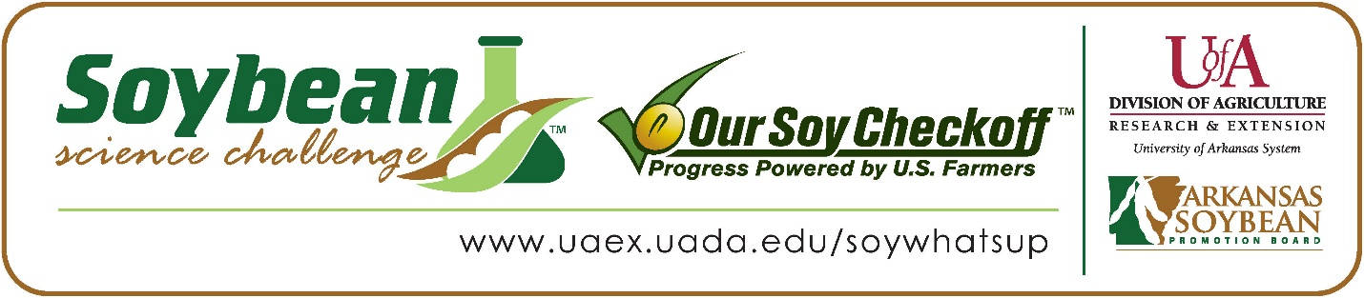
Me’Shelle Hinson wins 2024 Arkansas Soybean Science Challenge Junior Division Award at the Northeast Arkansas Regional Science Fair
Me’Shelle Hinson, age 12, a 7th grader at Paragould Junior High School in Paragould, Arkansas, won the Soybean Science Challenge Junior Division award at the 2024 Northeast Arkansas Regional Science Fair held at Arkansas State University on March 8.
Hinson received a $200 cash award provided by the Arkansas Soybean Promotion Board. Her science project was titled “Water filtration.”
Jennifer Langston, Hinson’s teacher, won the $100 Soybean Science Challenge Junior Division Teacher-Mentor Award. Langston stated that the Soybean Science Challenge is a great way for students to learn. “Introducing students to challenges such as the Soybean Challenge is beneficial for several reasons. Engaging students in real-world challenges provides them with practical, hands-on learning experiences. This type of learning can better their understanding of scientific concepts and agricultural practices. Challenges can spark student interest in agriculture and inspire them to pursue careers in STEM. By participating, students can gain exposure to real-world applications of their learning. Students are more motivated and engaged when they have a real-world context for their learning. Successfully completing a challenge can boost students' confidence in their abilities,” she replied.
Hinson was thrilled, but a bit awed to win the 2024 Junior Division Soybean Science Challenge. “I am excited to be the 2024 junior level winner,” she said.
Mr. and Mrs. Hinson were proud to see Me’Shelle receive the award. “We were surprised she had a project and were overjoyed that she won,” they responded.

Hinson found learning about soybeans and agriculture through the online course to be useful. “The part of the Soybean Science Challenge online course that appealed the most to me was the vocabulary, and learning about GMOs,” she explained.
Langston feels that the Soybean Science Challenge is a great program for students. “By having students participate in the Soybean Science Challenge, I gained teaching materials, lesson plans, and resources related to agricultural science, environmental sustainability, and STEM education. By using the curriculum, I was able to promote student engagement, independence, critical thinking, and problem-solving skills, as students worked to address real-world challenges. Participation in the Soybean Science Challenge offers teachers valuable opportunities for professional growth, curriculum enrichment, and student success, enhancing the quality of education provided to students,” she replied.
“The Soybean Science Challenge provides an opportunity for Arkansas junior high and high school students to participate in scientific research that can impact the State of Arkansas as well as the world. Soybean Science Challenge student researchers learn about this important commodity crop and its many uses including feeding the world, development of biofuels and sustainable products. The Soybean Science Challenge helps students develop an understanding of the challenges and complexities of modern farming,” said Dr. Julie Robinson, Professor, and director of the program.
“The goal of the Arkansas Soybean Science Challenge is to engage students in “real- world” education to support soybean production and agricultural sustainability,” said Gary Sitzer, a former member of the Arkansas Soybean Promotion Board. “The program also rewards scientific inquiry and discovery that supports the Arkansas soybean industry.”
The Arkansas Soybean Science Challenge was launched in January 2014 to 9-12th grade science students and in 2021, added grades 6-8 for the junior level award. Students who successfully completed the online course were eligible to have their original soybean-related research projects judged at the 2024 ISEF-affiliated Arkansas Science and Engineering Fairs.
Information on the 2024-2025 Arkansas Soybean Science Challenge will be available in summer 2024. For more information, contact Dr. Julie Robinson at jrobinson@uada.edu, Diedre Young at dyoung@uada.edu, or Keith Harris at kharris@uada.edu.
The Cooperative Extension Service is part of the University of Arkansas System Division of Agriculture.
Me’Shelle Hinson, Paragould Junior High School, Paragould, AR; Teacher: Jennifer Langston
Category: Environmental Science
Title: Water Filtration
Abstract: Some countries do not have access to clean water; they need to use water filtration systems. I used two types of water filters to filter dirty water. I then checked the pH level. The results showed the macaroni filter worked the best.

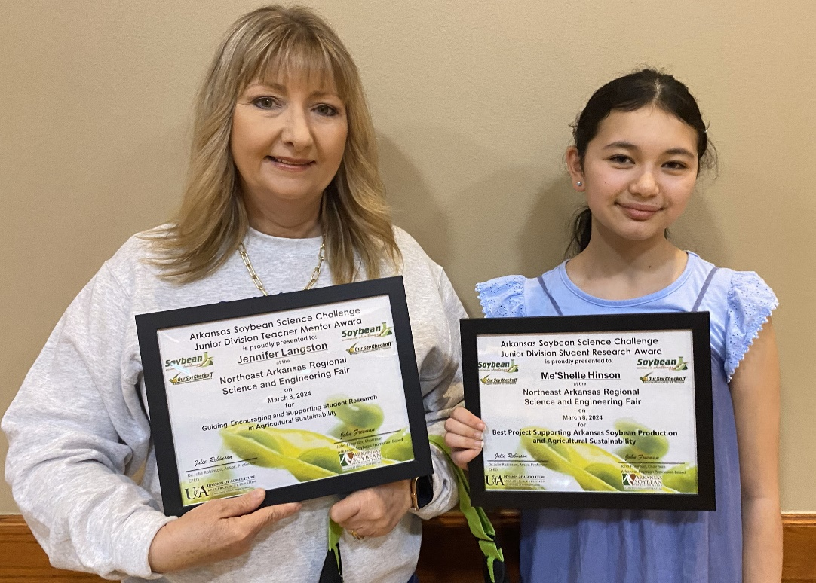

Soybean Science Challenge Junior Division Winner Me’Shelle Hinson and Teacher-Mentor Jennifer Langston

