2024 State Master Gardener Conference
Presentation Speakers (listed alphabetically)

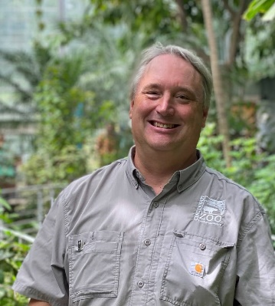
Beuerlein, Scott: “Good Trees for Bad Places”
Join Scott and learn about tough trees. Trees in this talk are survivors. They laugh at incorrect planting technique, scoff at mulch volcanoes, mock bad pruning cuts, and smirk at poor maintenance practices. They ask for poor soil. They taunt droughts. They are sometimes even found growing out of old toilets in piles of rubble from burned-out crack houses. Sure, some of the usual suspects, but also a bunch you probably don't know or didn't realize. Enjoy this romp through trees so ornery they'll resist the worst that is hurled at them and be there to shade your children's children. Scott is Manager of the Botanical Garden Outreach at the Cincinnati Zoo & Botanical Garden Cincinnati, Ohio. He is responsible for the Zoo's Botanical Garden, educational programs, various plant trialing programs, horticulturist in charge of plant trials, plant records and labeling, organizing, and running three large educational symposiums--Plant Trials Day, Effective Urban Sustainable Landscape Strategies Symposium, and Native Plant Symposium. Scott, who holds a B.A. in Communication Arts from Xavier University, is an ONLA Certified Landscape Technician and an ISA Certified Arborist. His writing skills have been recognized with numerous awards from the International Association of Garden Communicators. Chris currently pens two columns: the humorous “Deep Roots” column and the “Garden Views” series of interviews. Scott is a partner in the long running and highly respected Garden Rant blogsite with garden writer Marianne Wilburn.

Boerner, Talya: "An Introduction to Nature Journaling with Phenology Wheels"
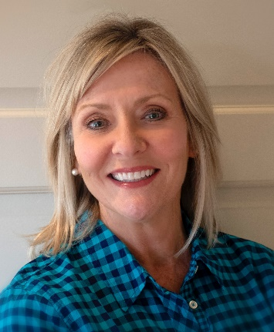
Talya Tate Boerner will take us on a journey of journaling phenology (the study of cyclic and seasonal natural phenomena, especially in relation to climate and plant and animal life). Talya is an author, reader, and nature enthusiast. After spending twenty-five years in Dallas as a commercial lender, she returned home to Arkansas ten years ago to pursue her dream of writing. Today, she is the author of three award-winning novels—The Accidental Salvation of Gracie Lee, Gene Everywhere, and Bernice Runs Away. Additionally, Talya’s work includes essays on home and farm, short stories, micro-fiction, and creative non-fiction. Her writing is always influenced by nature and nostalgia. Talya is also an Arkansas Master Naturalist (2018) and a Washington County Arkansas Master Gardener (2019). She and her husband live in a historic home in Fayetteville with their two miniature schnauzers. She grows a native pollinator garden, works to attract a variety of birds to her feeders, and regularly (over)shares on her lifestyle blog, Grace Grits and Gardening. Talya tries to do something creative every day.

Carson, Janet: "Planting for Continuous Color"
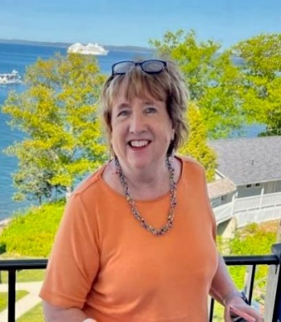
Janet Carson, a long-time favorite of our Master Gardener community, will discuss plants for your landscape to ensure year-round color and interest. Since starting the Master Gardener Program in Arkansas 1980, she has continued to educate and entertain us in her talks and her writing. Carson spent 38 years with the Cooperative Extension, and, since retiring, has continued to write columns for the Arkansas Democrat-Gazette and Arkansas Living magazines, along with a blog Plan it Janet.
Carson is a recipient of the John White Award for Excellence in Extension Education, the Extension Educator Award from the American Society for Horticultural Science, the Extension Employee of the Year, and the UA Horticulture Outstanding Alumni Award. Her first book In the Garden was published in 2010, and her second book Field to Feast was published in 2016, both by the Arkansas Democrat-Gazette. She frequently leads garden travel programs, and now gets to spend more time in her own garden. She earned both a BS and MS degree from the University of Arkansas.

Cooper, Chris: "Integrated Pest Management for Pollinator Plants"
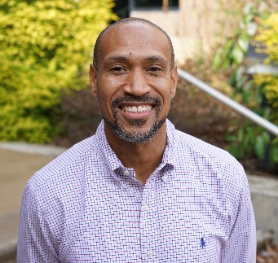
Dr. Chris Cooper will explain how to manage a landscape or garden with less chemical intervention and to maximize use of pollinator plants. Chris is a University of Tennessee Extension County Director and Coordinator for the Extension Master Gardener Program in Shelby County. Chris can be found throughout Shelby County conducting educational programs addressing issues that affect urban and home horticulture. He has a B.S. degree in Soil Science from Southern University, Baton Rouge, LA., and a M.S. and Ph.D. in Plant Physiology from Alabama A&M University, Huntsville, AL. Chris is the host of the series “The Family Plot: Gardening in the Mid-South” which can be found on WKNO/Channel 10 (PBS) on Saturdays at 3:00 pm and Sundays at 12:30 pm.

Daniels, Mike: "Master Gardeners Can Help Protect the Environment"
Dr. Mike Daniels will discuss how we can use a variety of techniques to minimize soil erosion and conserve water resources. Mike has served as a Soil and Water Conservation Specialist for the University of Arkansas System Division of Agriculture’s Cooperative Extension Service for the past twenty-seven years. During this time, Dr. Daniels has developed and implemented innovative Extension programs as well as conducted applied research to help agricultural producers and conservation professionals address soil- and water-related issues facing Arkansas agriculture. His program has emphasized application of soil and water conservation practices to improve water quality, soil health, increase irrigation water use efficiency and reduce nutrient losses in runoff. He is Director of the Arkansas Discovery Farms program where the impact of agricultural practices on water resources is documented on private farms and agricultural producers are included in the solution process in resolving water-related issues.

Hahn, Minnie: "Get Basic – Intro to Landscape Design"
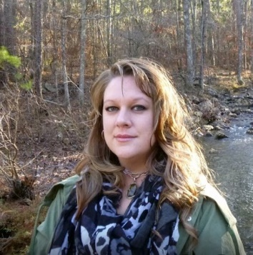
Minnie Hahn will guide you through principles to apply when planning a colorful and beautiful landscape, the same techniques she applies at Garvan Woodland Gardens. Minnie’s education includes a Master of Science degree in Horticulture from Kansas State University. She has been an avid gardener since she was able to hold a trowel and became interested in the design aspects of landscaping through the influence of a close family friend who was a landscape architect based out of Washington, D.C. During her college education, she studied landscape design, as well as obtaining her teaching license for high school science. While pursuing her master’s degree, she worked as a landscape designer for K-State Research and Extension and worked for the Denver Zoological Gardens. After graduating, Minnie and her three fur babies moved to the Kansas City area to be near family where she taught high school science classes for 8 years. In 2014 Minnie followed her passion for gardening and design to Hot Springs, AR and has since become the Senior Manager of Design and Display at Garvan Woodland Gardens, where she is able to apply her knowledge and artist talent in both horticulture and design.
Kooiman, Lizzy: "Growing and Using Cut Flowers"
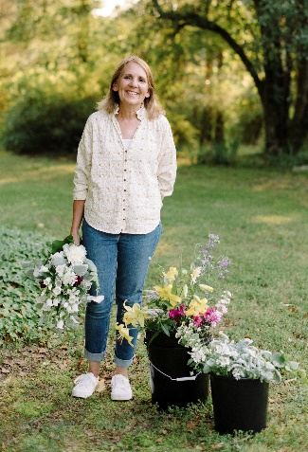
Learn about planting, harvesting, and using cut flowers to brighten your mood and environment. This is what Lizzy Kooiman did. After raising her family and spending 25 years as a pediatric nurse in the Pediatric Intensive Care Unit and later in the Cardiac Catheter Lab at Arkansas Children’s Hospital, Lizzy retired and started her small specialty cut flower farm at her home in Central Arkansas, The Poppy Patch. Although she didn’t recognize it at the time, during her years as a nurse, she used gardening and the flowers she gathered and arranged as a form of therapy to help her cope with the stresses of caring for extremely ill children and their families. Now in her 5th season, she sells her flowers to florists, wedding and event designers, individuals and offers on-farm opportunities such as workshops, U-Picks, and a roadside farm stand. Lizzy has been a lifelong lover of nature and the outdoors, spending as much time as possible outside with her hands in the dirt.

Malone, Karen: “How to Successfully Grow a Wildflower Plot”
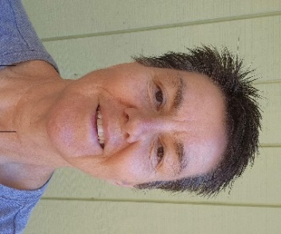
Karen Malone will show you how to create that beautiful wildflower meadow that you’ve dreamed about. She will discuss plants helpful to the beneficial creatures and selecting plants that provide year-round interest, habitat, and nutrition. Karen is currently the Horticulture Manager at Garvan Woodland Gardens. After an initial career teaching science at the secondary level, she returned to school for a master’s degree in environmental science from the Arthur Temple School of Forestry at Stephen F Austin State University. She loves many types of gardening but is especially fond of working with nature and the use of native plants.

McWhirt, Amanda: "Tips to be Berry Successful: Gardening Small Fruit in Arkansas"
Interested in growing strawberries, blackberries, raspberries, or blueberries? Dr. Amanda McWhirt can help you get started. She has served as an Assistant Professor in the Department of Horticulture at the University of Arkansas and as the statewide Fruit and Vegetable Production Extension Specialist since 2016. Dr. McWhirt’s research program focuses on improving the efficiency and productivity of small fruit production systems and includes work on alternative trellising methods for blackberry, planting date and fall row cover use for plasticulture strawberry production and evaluations of nutrient and soil management practices. To support the expanding small fruit industries in the Southeast she has led blackberry, strawberry and blueberry production workshop series which have reached over 700 growers and stakeholders. Dr. McWhirt is a board member of the North American Strawberry Growers Association (NASGA) and represents region 6 on the North American Raspberry and Blackberry Growers Association (NARBA) executive council. She holds a Ph.D. from North Carolina State University in Crop Science-Agroecology, a M.S. in Soil Science from Louisiana State University and B.S. in Horticulture from Tarleton State University. Dr. McWhirt served as a Peace Corps Volunteer in Honduras from 2008-2010.

Nash, Dee: "How to Manage Your Landscape Without Going Crazy (Tips for Any Size Garden)"
Want to know useful tips and the best tools for a specific gardening job? Dee will entertain you with her wealth of knowledge and show you how she maintains her beautiful home landscape. Dee Nash, an Oklahoma native, author, podcaster, and blogger, is best known for her blog, Red Dirt Ramblings, which has won the Garden Writers Association’s Gold Award for Best Electronic Writing. Better Homes and Gardens named it to the Top Ten Gardening Blogs, and Southern Living magazine named Dee Nash one its “30 Bloggers to Follow.” Her book, The 20-30 Something Garden Guide: A No-Fuss, Down and Dirty, Gardening 101 for Anyone Who Wants to Grow Stuff (St. Lynn’s Press), will be available for sale at the conference. Dee has been a featured keynote for conferences such as the Oklahoma Organic Gardening Association, Oklahoma Horticultural Society and Northwest Flower and Garden Show in Seattle. She holds a bachelor’s degree in journalism, professional writing, from the University of Oklahoma with an emphasis in Botany.

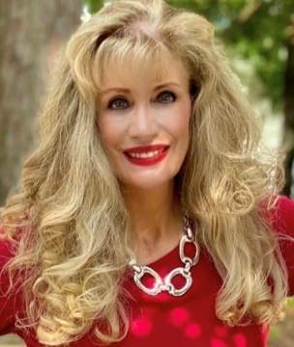
O’Neal, Charlene: "An empty container is a garden looking for a place to happen."
Using an entertaining and informative demonstration, Charlene O’Neal will show you how to create an eye-catching display in containers of many sizes to brighten up a porch or patio. Charlene is a real estate agent working at McGraw Realtors in Hot Springs. Many years ago, when she started work career, she was doing property management and living on site. Since she could not plant a garden, she started making container gardens. She also noted that she could take her plants with her when jobs changed and could also change out the plants whenever she wanted. She fell in love with container gardening. She became a Master Gardener in Garland County in 2021. She has a website (House of Char Design) where she sells her garden containers and offers free advice on gardening in general.

Palmer, Linda: “Champion Trees of Arkansas”
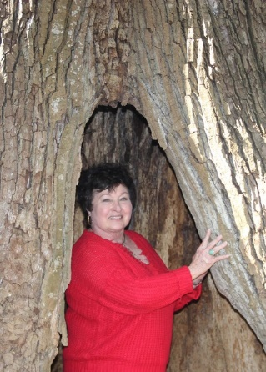
Learn all about the giant trees located throughout Arkansas. The champion tree project began in 2007 when Linda Palmer viewed the list of Arkansas's largest examples of each species of tree, determined by the Arkansas Forestry Commission. Travelling more than 20,000 miles crisscrossing the state to photograph trees, Linda has to date created 26 large-scale portraits of Champion Trees of Arkansas. Her touring exhibit, launched in 2012, and visited 21 venues through 2016. Collecting oral histories of the trees along the way from the families and communities that love them and keeping a journal of her adventures inspired Linda to envision her book Champion Tree of Arkansas; An Artist’s Journey. Her series also formed the basis for Arkansas Educational Television Network’s documentary “Champion Trees,” which has won state, National and International awards and can now be seen on National PBS Stations. Linda began her visual arts career in 1980, studying with Don Lee at the University of Arkansas at Fort Smith. In 1991, she moved to Hot Springs, Arkansas, establishing her gallery and studio in the city’s Historic Arts District.

Randel, Bill: “I Never Met A Tree I Didn’t Love”
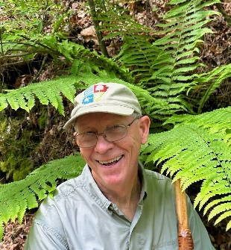
Bill Randel is an expert at tree identification and will help you improve your own skills in this class. He is known as a humorist/storyteller, who conducts educational hikes, with emphasis on trees and shrubs, for Diamond Lakes Arkansas Master Naturalists. He is active in the Arkansas Native Plant Society and is a retired data systems engineer who also holds a BA in Biology from Hendrix College and a MS in Plant Ecology and Plant Biochemistry from Western Kentucky University. He taught at National Park College for 10 years during his “retirement”.

Rudolf Melanie: “Benefits of Prescribed Fire in Native Plant Communities”
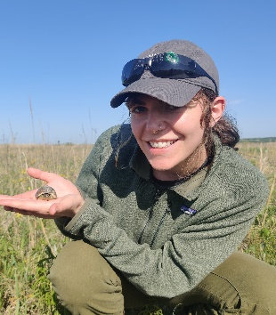
Melanie is a Terrestrial Restoration Ecologist at The Nature Conservancy in Arkansas. She will be discussing the history of ecology and fire of Arkansas, plants and ecosystems response to fire, and how prescribed fire can be used to restore and benefit natural ecosystems. Her work includes plant community monitoring, scientific research, fire ecology, and ecosystem restoration. She holds a Bachelor of Specialized Studies in Environmental Biology and Sustainability, and a Master of Science in Environmental Studies. Her graduate research focused on the effects of invasive species on ecosystem structure and function in wetlands.

Rushing, Felder: "Pass-Along plants"
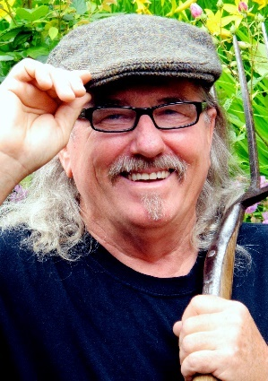
Learn about the beautiful, dependable, and sometimes forgotten or overlooked plants (not often in nurseries) that make great additions to your garden. Felder Rushing is an 11th- generation Southern gardener who travels worldwide in his quest for practical and inspirational home-gardening ideas to share. Widely promoting his belief that too many garden-variety gardeners are put off by strict horticultural, Felder’s encouraging approach to teaching gardening earned him a celebration by Southern Living Magazine’s as one of “25 people most likely to change the South.” The retired colors-outside-the-lines Extension Horticulturist, who started the Master Gardener program in his state, continues to write his state-wide syndicated newspaper columns of 43 years and counting, and for 21 years remains the host the weekly live Gestalt Gardener program, one of National Public Radio’s most popular gardening programs, broadcast from his travels around the country and world. He has written or contributed substantially to 33 gardening books, numerous magazine articles and national award winner books such as Passalong Plants, Slow Gardening, Better Homes and Garden’s children’s gardening book, and Maverick Gardeners. For the past 14 years he has traveled, lectured, and reported from both his celebrated Mississippi cottage garden and a Victorian terrace herb and succulent garden in Lancashire, England.

Schrader, Bruce: "Growing a Salad for Everyday in a 4 ft Square Garden."
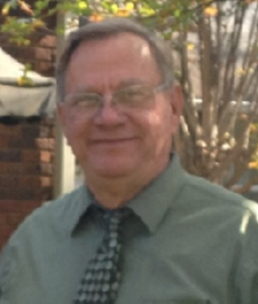
Bruce Schrader will amaze you with his vast knowledge of vegetable gardening. He has been a been a gardener for forty+ years and during most of those years raising his own home half-acre to an acre garden. In 2012, he became a Master Gardener and is a member of Saline County MGs. In 2012 he also started the Avilla/Zion Community Garden and became the Chairman of the Garden Board. This will be the 13th year for the Avilla/Zion Community Garden project and Bruce works with 30 to 60 families each year who have personal garden beds. He and his fellow gardeners serve the community through different groups in the garden. He also teaches 6 to 8 sessions each spring in a “how to grow a garden and what to plant” series. Bruce has a BSE and MSE from University of Central Arkansas and spent 38 years in elementary education with 35 as a building level Principal. Thirty of his 38 years were in public education and then 8 years in Lutheran Schools.

Scoog, Ned: "Nighttime Outdoor Illumination: A Better Way"
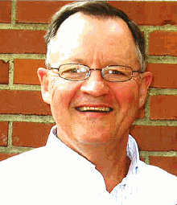
What are bright lights doing to our environment? Ned will guide you through the issues and give you better options for your landscape. Ned Skoog is a native and lifelong resident of Hot Springs. He is a graduate of Hot Springs High School, and he has a bachelor’s degree in engineering from the University of Arkansas. He is active in many Hot Springs community activities and is currently on the steering committee of the statewide Arkansas Natural Sky Association. He is a board member and president of the Hot Springs Friends of the Parks, a board member of the multi-state Friends of the Ouachita Trail, a past board member of numerous community organizations including the Hot Springs YMCA, the Garland County United Way, the Garland County Industrial Development Committee, and the Garland County Planning Study Committee. Ned has a significant interest in nature preservation, conservation, and healthy outdoor opportunities. He has 49 years of experience in manufacturing management and process design/implementation. His manufacturing experience includes large facilities with a high degree of automation.

Skelton, Regine: “Trees Serving Pollinators”
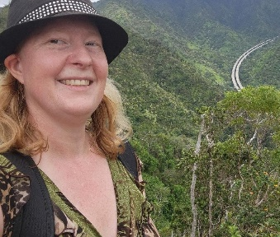
As modern landscapes change, pollinators fight to survive, and they need our help. Trees are just as critical for pollinators and support an even greater diversity of butterflies and moths than herbaceous plants. Native oak trees support pollinators throughout the year in several ways, but especially by providing winter shelter and habitat. Regine Skelton, Forester II, and is the Registered Forester #1492 for Garland and Clark Counties. She received her degree from Steven F Austin State University, Austin, TX, where she specialized in fire management. At the Arkansas Forestry Commission, she serves as the urban representative for the six-county district. She has received several awards serving in the Arkansas Forestry Association American Tree Farm System Program as a regional chair and inspector.

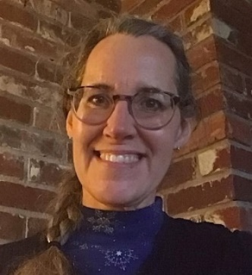
Tooke, Jodi: "Ferns and Mosses: Seedless Wonders"
\Do you have a difficult shady area and no idea how to landscape it? Join Jodi Tooke to learn more about the wonderfully diverse and beautiful mosses and ferns that abound. Jodi is a volunteer with the Garland County Master Gardeners program. She retired from the Air Force after 28 years in 2014 and settled in Hot Springs on Lake Hamilton with her husband Sam. Fascinated by what grows well and not so well, she considers her landscape one big experiment. She became a Master Gardener in 2015 to learn about plants and what makes each special and to help others do the same. Finding the right plant for the right space means exploring natives, invasives and traditional ornamentals—coming to terms with how and why they prosper. Her interest in ferns and mosses comes from wanting to understand the environment she shares with the natural flora and fauna of Arkansas.

Debbie Tripp: "Spice Up Your Life with Herb Gardening"
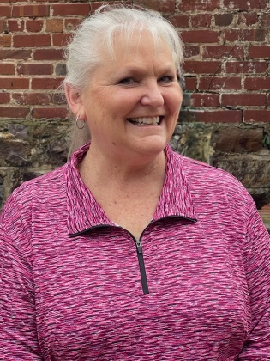
Debbie Tripp is the owner of Rosemary Hill Herb Farm in Crystal Springs, AR which features both familiar and hard-to-find starter herb and pollinator plants. She also serves as the Vice President of the Herb-N-League, an Educational/Garden Club in Hot Springs, and has been a Master Gardener since 2018. She has a BSE in Mathematics and is a retired high school math teacher. Although not in formal education any longer, Debbie continues her love for teaching and learning combined with her love of herbs by sharing that knowledge whenever possible. Her speaking engagements have included hands-on workshops, cooking classes, as well as presentations in venues such as the Arkansas Flower and Garden Show, Garvan Woodland Gardens, Arkansas Chapter of the Herb Society of America, Arkansas Homesteading Conferences, Jefferson County Home and Garden Show, as well as for many civic groups, beekeepers, and garden clubs. There is always something new to learn about herbs whether it involves their growing habits, culinary uses, medicinal properties, or a new herbal craft idea. Sharing that knowledge with others is a natural progression whether it is through her herb business, presenting to eager groups like the Master Gardeners, or in our Herb-N-League meetings.

