  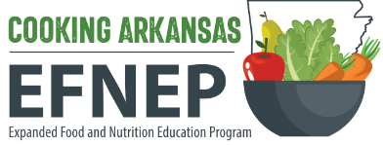 |  |  |  |  | EFNEP Purchase Justification Form |  |  |  |  |  |  |  |  |  | PURCH-331  07-31-2024
EFNEP Supervising Agent |  |  |  |  |  |  |  |  | County
EFNEP Educator |  |  |  |  |  |  |  |  | Date
PLEASE COMPLETE FOR ALL PURCHASES (FOOD AND NON-FOOD)
1. | Please provide a justification for how the nutrition education materials/food demonstration supplies purchased are to be used to support EFNEP programming. (Be specific.)
2. | List approved curriculum and lesson name that this purchase supports:
3. | If the purchase is for food demonstration materials and supplies, list the recipe(s) being demonstrated and the curriculum or source of the recipe(s). (Please attach a copy of the recipe if the recipe is not from an approved source. Recipes from non-approved sources should be reviewed in advance by EFNEP state staff.)
4. | Indicate the number of participants attending the programs for which items were purchased:
 |  |  | Adult Participants |  |  |  |  | Youth Participants |  |  |  |  | EFNEP Volunteers
 |  |  | Others (Please specify)
Total Cost
EFNEP Supervising Agent Signature |  |  |  |  |  |  |  |  |  |  | Date
EFNEP LRSO Signature |  |  |  |  |  |  |  |  |  |  | Date
IMPORTANT: This form must be attached to all p-card verifications and reimbursement requests in Workday. Additional paperwork may be required per Finance Department policies.

