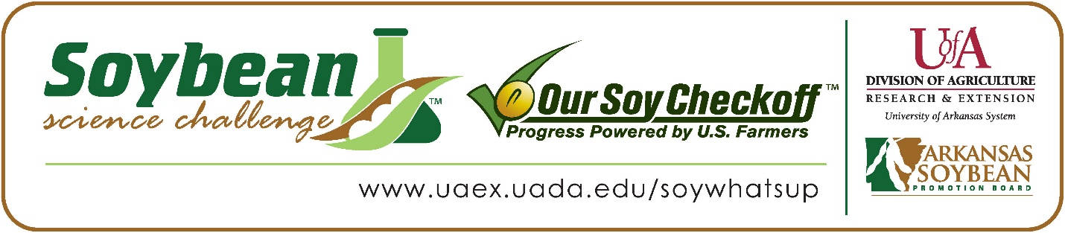

**Alexander Pagliani wins the 2025 SR Division Arkansas Soybean Science Challenge Award at the Northwest Arkansas Regional Science and Engineering Fair**

Alexander Pagliani, 16, a junior at Fayetteville Christian Academy in Fayetteville, won the Senior Division Soybean Science Challenge at the 2025 Northwest Arkansas Regional Science and Engineering Fair at the University of Arkansas-Fayetteville on March 7.

Alexander received a $400 cash award provided by the Arkansas Soybean Promotion Board. His science project was titled “Wood treatment with soy oil.”

Alicia Deavens, Alexander’s teacher, won the $200 Soybean Science Challenge Teacher- Mentor Award. Deavens stated that the Soybean Science Challenge is a great way to learn about soybean research. “I encourage my students to participate in the Soybean Science Challenge because it is a great educational opportunity for the students as they can learn about science as well as highlight an amazing soybean industry in our great state of Arkansas. By participating in The Challenge, I gained another opportunity to share and highlight the benefits of the soybean industry in Arkansas. We have used resources from the Soybean Challenge in other classes from fourth grade through High School. The joy and honor of mentoring students as they participate and see their hard work honored is such a blessing and inspiration for everyone – students, parents, and the community,” she replied.

Pagliani was thrilled to win the 2025 Soybean Science Challenge. “Winning the 2025 Senior Level Soybean Science Challenge is an incredible honor! It provides a platform to share my findings and contribute to the ongoing conversation about sustainable agriculture. I believe it also inspires others to engage in agricultural research and innovative practices,” he stated.

Pablo and Lisa Pagliani, Alex’s parents, were proud to see him receive the award. “We were very excited and happy for Alexander! It's great to see his project recognized and awarded, and we are extremely proud of the work and research he has put forth to participate in the Soybean Science Challenge,” they replied.

Alexander feels that the Soybean Science Challenge is a great program for students. “The most appealing part of the online course was the interactive modules that allowed for hands-on learning. Engaging with real-world data and scenarios provided a deeper understanding of soybean cultivation and its impact on sustainability. I also found the sections on pest management and crop rotation particularly interesting. The discussions on sustainable farming practices and their role in minimizing environmental impact highlighted the importance of maintaining biodiversity and soil health for agricultural crops. Participation in the Soybean Science Challenge provided me with invaluable knowledge about soybean agriculture and sustainability. It also enhanced my research skills, taught me how to analyze data effectively, and fostered a passion for agricultural science that I intend to pursue further,” he explained.

“The Soybean Science Challenge provides an opportunity for Arkansas junior high and high school students to participate in scientific research that can impact the State of Arkansas as well as the world. Soybean Science Challenge student researchers learn about this important commodity crop and its many uses including feeding the world, development of biofuels and sustainable products. The Soybean Science Challenge helps students develop an understanding of the challenges and complexities of modern farming,” said Dr. Julie Robinson, Professor and director of the program.

“The goal of the Arkansas Soybean Science Challenge is to engage students in “real- world” education to support soybean production and agricultural sustainability,” said Gary Sitzer, a former member of the Arkansas Soybean Promotion Board. “The program also rewards scientific inquiry and discovery that supports the Arkansas Soybean Industry.”

The Arkansas Soybean Science Challenge was launched in January 2014 for 9-12th grade science students. Students who successfully completed the online course were eligible to have their original soybean-related research projects judged at the 2025 ISEF-affiliated Arkansas Science and Engineering Fairs.

Information on the 2025-2026 Arkansas Soybean Science Challenge will be available in summer 2025. For more information, contact Dr. Julie Robinson at [jrobinson@uada.edu](mailto:jrobinson@uada.edu), Keith Harris at [krharris@uada.edu](mailto:krharris@uada.edu), or Diedre Young at [dyoung@uada.edu](mailto:dyoung@uada.edu).

The Cooperative Extension Service is part of the University of Arkansas System Division of Agriculture.

**Alexander Pagliani, Fayetteville Christian School, Fayetteville, Arkansas; Teacher, Alicia Deavens**

**Category: Plant Sciences**

**Title: Wood treatment with soy oil**

**Abstract:**

This study focuses on the effects of soybean oil on wood preservation, specifically examining four key aspects: color retention, fire resistance, surface scratching, and water absorption in four wood species. The findings indicate that soybean oil effectively preserves the original colors of Birch and Oak, while Pine and Cedar experience more significant color changes when treated with soybean oil compared to untreated or water-treated samples. This demonstrates that the impact of soybean oil can differ depending on the type of wood. In terms of fire resistance, soybean oil offers moderate protection, outperforming untreated Oak but falling short compared to water treated wood. Notably, untreated Birch shows better fire resistance than treated wood, emphasizing the complex relationship between wood characteristics and treatment methods. Additionally, while soybean oil does not significantly enhance scratch resistance for Birch, Oak, or Pine, it effectively reduces water absorption in all wood types tested, making it a promising option for moisture resistance. Overall, while soybean oil presents certain advantages in wood preservation, its effectiveness varies by wood species and preservation objectives, highlighting the necessity of considering the unique properties of each wood type when using soybean oil as a treatment.

Soybean Science Challenge SR Division Winner Alexander Pagliani and Teacher/Mentor Alicia Deavens