

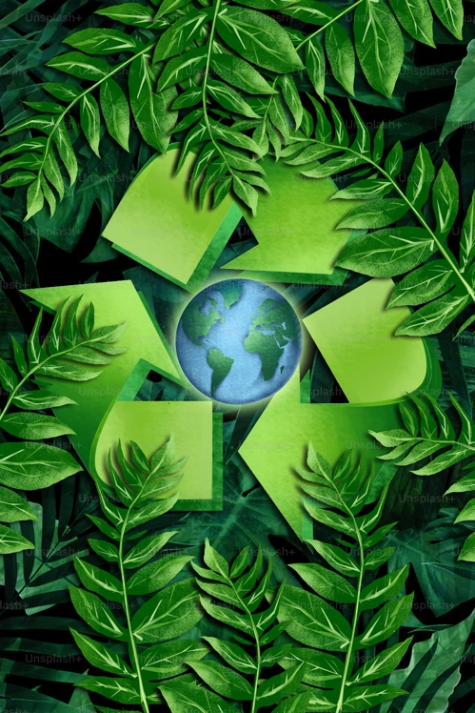
By Diedre Young MAT, Soybean Science Challenge

Arkansas NGSS Standards Suggestions:

Integrated Biology:

Topic 3: Biodiversity and population dynamics.

BI-LS2-7: Design, evaluate, and refine a solution for reducing the impacts of human activities on the environment and biodiversity.

Topic 6: Life and Earth Systems

BI6-ETS1-3: Evaluate a solution to a complex real-world problem based on prioritized criteria and trade-offs that account for a range of constraints, including cost, safety, reliability, and aesthetics, as well as possible social, cultural, and environmental impacts.
Photo from Unsplash

BI6-ETS1-2: Design a solution to a complex real-world problem by breaking it down into smaller, more manageable problems that can be solved through engineering.

Topic 7: Human impacts on Earth Systems.

BI-ESS3-2: Evaluate competing design solutions for developing, managing, and utilizing energy and mineral resources based on cost ratios.

BI7-ETS1-1: Analyze a major global challenge to specify qualitative and quantitative criteria and constraints for solutions that account for societal needs and wants.

Science and Engineering Practices:

Constructing explanations and designing solutions. (BI-LS2-7, BI6-ETS1-3, BI6-ETS1-2)

Engaging in argument from evidence. (BI-ESS3-2)

Asking questions and defining problems. (BI7-ETS1-1)
Disciplinary Core Ideas:

LS4.D: Biodiversity and Humans. (BI-LS2-7)

ETS1.B: Developing Possible Solutions. (BI6-ETS1-3, BI6-ETS1-2)

ESS3.A: Natural Resources: (BI-ESS3-2)

ETS1.A: Defining and Delimiting Engineering Problems: (B17-ETS1-1)

Crosscutting Concepts:
Stability and Change: (BI-LS2-7)
Influence of engineering, technology, and science on society and the natural world. (BI6-ETS1-3, BI-ESS3-2, BI7-ETS1-1)

Connections to the Arkansas Disciplinary Literacy Standards:
RST.11-12.1, RST.11-12.8, RST.11-12.9

Connections to the Arkansas Mathematics Standards:
MP2, MP4, HSN.Q.A.1,2,3.
Integrated Chemistry:
Topic 3: Energy Flow

CI-ESS3-4: Evaluate or refine a technological solution that reduces impacts of
Human activities on natural systems.

CI3-ETS1-1: Analyze a major global challenge to specify qualitative and quantitative
criteria and constraints for solutions that account for societal needs and wants.

Science and Engineering Practices:

Constructing explanations and designing solutions. (CI-ESS3-4)

Asking questions and defining problems. (CI3-ETS1-1)
Disciplinary Core Ideas:

ESS3.C: Human impacts on Earth systems. (CI-ESS3-4)

ETS1.A: Defining and Delimiting Engineering Problems. (CI3-ETS1-1)
Crosscutting Concepts:
Stability and change. (CI-ESS3-4)

Influence of Engineering, Technology, and Science on Society and the Natural World. (CI3-ETS1-1)
Connections to the Arkansas Disciplinary Literacy Standards:

RST.11-12.1,7,8,9

Connections to the Arkansas Mathematics Standards:

MP.2,4, HSN.Q.A.1,2,3

Objective: Investigate the structure and function of petroleum-based plastics; the development of plastics from potentially (more) ecofriendly alternatives; and evaluate both for viability, sustainability and economic impact.

Assessment: Students will fill out the attached lab sheet and turn it in for assessment.

Key Points: bioplastics, petroleum plastics, human impact, economic impact, ecological impact, and ecological friendly alternatives.
Materials: A microwave, ruler, tin foil, scissors, Ziplock© sandwich bags (two per group), various small coins or other metal objects, scales, containers with small openings (the cut-out bottom of a small plastic cup works well), vegetable-based glycerin, cornstarch,
vinegar, and water.

Preparation: About 10-20 minutes depending on class size.

Time duration: One class period.
Elicit: Do a KWL chart about what students know about how plastics are made and what they are made from.

Engage: Each of these videos are approximately 3-5 minutes. You can pick and choose.

https://www.youtube.com/watch?v=9GMbRG9CZJw History of plastics.

https://www.youtube.com/watch?v=w4VG-7ZFvDM Animation of making of petroleum plastics.

https://www.youtube.com/watch?v=Yomf5pBN8dY This video talks about the ecological effects of plastics.

https://www.youtube.com/watch?v=_6xlNyWPpB8 Why we should recycle plastic.

https://www.youtube.com/watch?v=PNyrVu-NAk0b What are bioplastics.

Explain: Students should now understand that using petroleum plastics comes with an ecological cost. While recycling is a viable option for plastics, too little plastic is recycled to make this a good alternative. 90% of all plastics produced end up in landfills where toxic chemicals that are used to make plastics leach out and eventually end up in our groundwater. Plastics can take up to 1,000 years to degrade (10-20 years for a plastic bag and 450 years for a plastic bottle), so they hang around for a very long time. As plastics degrade, they form microplastics. These microplastics are ingested (either by eating or drinking) by animals and by humans. The ecological impact of plastics on our waterways is staggering. Microplastics eaten by zooplankton (that think it’s food) die of starvation, and this has caused a large decrease in this food source for all species of fish larvae. Plastics choke, maim etc. aquatic animals that get tangled in them and it has caused major issues.
Bioplastics could be a sound alternative to petroleum plastics. They are biodegradable (some are even recyclable) and made from plant-based ingredients. The real question is, can bioplastic compete with regular plastic in a normal usage setting? Are bioplastics an economically sound solution to replacing petroleum plastics? *

*Teaching suggestion: If you are teaching Chemistry II or Advanced Chemistry,
consider discussing the polymerization of both petroleum and bioplastics.

Elaborate: Students will be placed into groups of three to four students. Each group will be given (or will need to retrieve) two sandwich size Ziplock© bags, scissors, a sheet of tin foil, *2 tbsp of water, 2 tbsp of cornstarch, 1 tsp of vinegar, 1 tsp of glycerin and a ‘rolling pin’ (or a can, to be covered in a thin layer of vegetable oil) to roll out the bioplastic. They also need to retrieve a ruler, plastic cup with the bottom cut out, and various small metal objects for the actual experiments. *These measurements can be given in metric.

The Experiment:

Each group will do the following:

- In a bowl (optional) or resealable bag, combine the cornstarch, water, vinegar, and glycerin.
- Stir or massage the mixture until well combined.
- Microwave the mixture on high for 30 seconds.
- Immediately remove it from the bag (cut open bag) onto the piece of tin foil (IT WILL BE HOT!!!) and roll it to a flat plane of equal thickness throughout the plastic. DO NOT MAKE IT THIN! LEAVE IT THICKER! Make sure your ‘roller’ has a thin layer of vegetable oil, or the roller will stick to the plastic. Let the bioplastic then cool for about 10 minutes (it can be placed on ice or in a fridge to decrease wait time).

Each group will then ‘test’ their bioplastic against a single layered Ziplock bag (the bag is cut open and laid flat). It will be a ‘stretch’ test, a ‘weight’ test, and a ‘waterproof’ test. Remember, this will ALSO include the Ziplock bag as a ‘standard’ to measure by.

1). Stretch test: Measure the length of a strip of unstretched bioplastic. Now, slowly stretch two opposite ends of the plastic until right before it breaks. Measure the distance the bioplastic stretched. Do this also with a same width single layer Ziplock© bag.

2). Weight test: obtain various small objects. Hold a wide section of bioplastic at the four corners (and center edges if need be) and then slowly add weight until the plastic starts to break. Weigh the total number of objects. Do the same with the Ziplock© bag.

3). Waterproof test: stretch the bioplastic over a small sized hole, forming a concave
center. Secure with a rubber band (if needed). Slowly pour a small amount of water in the center (DO NOT OVERFILL!) then time for 10 minutes. Check for water leakage at the bottom of the container. Do the Ziplock© bag too!

The results:
- Students will discuss in their group the results of their bioplastics test.

- Each group will tell the rest of the class their bioplastics results. *

*Teachers: Students will most likely have different answers for the same test on their bioplastics. Discuss with the class why this may have happened.

- Each student fills out a form individually with their answers to be submitted for grading. These can be turned in at the end of the period or the next day.

Evaluate: Students will hand in their ‘lab sheet’ for evaluation.

NOTE:
The bioplastic will not hold up to the plastic bag. Discuss with your students why this may be the case and what can be done to improve the bioplastic.
Extend:
Consider having the students do three different types of bioplastics using three different types of glycerin; soybean, palm, and coconut based. These glycerin’s can be ordered online. *
*Suggestion: Have the students add a different food color for each of the three bioplastics they are going to make.
Have a local recycling company spokesperson visit and speak about the importance of plastic recycling in the community.
Have the students do an economic study on the cost of bioplastic production and the carbon footprint caused by it, comparing it to the cost of production and carbon footprint of petroleum plastic.

Bioplastics lab sheet
*DO QUESTION ONE BEFORE TESTING!
1). Which (bioplastic or the Ziplock© bag) do you think will do the best? (there is no right, or wrong answer so fill this out before you do the experiment), and why do you think this?

2). Write the data below from the results of your bioplastics experiment.
Stretch:
Weight:
Waterproof:

3). Write the data below from the results of your Ziplock© bag experiment.
Stretch:
Weight:
Waterproof:

5). Based on your data, which plastic did the best?

6). Was your hypothesis correct or not?

7). Based on the information you got from your data, what is your conclusion about how bioplastics hold up against regular plastic?

8). Currently it’s more expensive to make bioplastics than petroleum plastics and there is data that shows bioplastic carries its own significant carbon footprint in production. What are your thoughts about this economic issue?

The University of Arkansas System Division of Agriculture offers all its Extension and Research programs to all eligible persons without regard to race, color, sex, gender identity, sexual orientation, national origin, religion, age, disability, marital or veteran status, genetic information, or any other legally protected status, and is an Affirmative Action/Equal Opportunity Employer.

