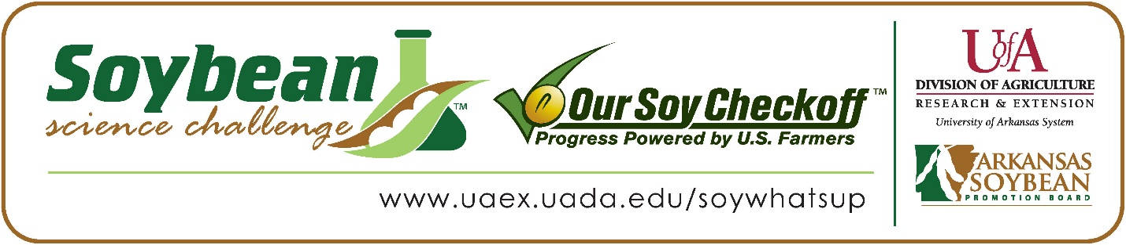

**Quentin Gantt wins 2025 Arkansas Soybean Science Challenge Senior Division at Northeast Arkansas Regional Science Fair**

Quentin Gantt, 18, a senior at The Academies at Jonesboro High School won the 2025 Senior Division award at Northeast Arkansas Regional Science Fair at Arkansas State University Jonesboro March 7.

Gantt received a $400 cash award for his regional win. Awards were provided by the Arkansas Soybean Promotion Board. His science project titled “The effects of high pH solution on the growth of soybeans” placed second in plant science.

Allyson Goodin, Quentin’s teacher, won the $200 regional teacher/mentor award. Goodin stated that the Soybean Science Challenge is a great way to learn about the science behind soybeans in the classroom. “The SSC is a great program that allows the students to learn at their own pace, and it is a wonderful educational experience for my students,” she explained.

Quentin said he was happy to win the Senior Division Soybean Science Challenge. “I never thought that I would win but I did anyway. If I can win, you can win. This was my first high school level science fair,” he replied. Chemeka Gantt, Quentin’s parent, was very proud to see him receive the award.

Goodin expounded on why the Soybean Science Challenge is so important. “Quentin learned new information about the importance of soybeans in Arkansas and the world. This also gave him an opportunity to practice the scientific method,” she stated. “I have gained new respect for Soybean farmers and the amazing plant,” she concluded.

Quentin explained what he had learned about participating in The Challenge. “Through The Challenge I learned that soybeans are a valuable food source. I also enjoyed learning about the different nutrients that soybeans provide,” he explained.

“The Soybean Science Challenge provides an opportunity for Arkansas junior high and high school students to participate in scientific research that can impact the State of Arkansas as well as the world. Soybean Science Challenge student researchers learn about this important commodity crop and its many uses including feeding the world, development of biofuels and sustainable products. The Soybean Science Challenge helps students develop an understanding of the challenges and complexities of modern farming,” said Professor Julie Robinson, director of the program.

“The goal of the Arkansas Soybean Science Challenge is to engage students in “real- world” education to support soybean production and agricultural sustainability,” said Gary Sitzer, a former member of the Arkansas Soybean Promotion Board. “The program also rewards scientific inquiry and discovery that supports the Arkansas Soybean Industry.”

The Arkansas Soybean Science Challenge was launched in January 2014 for 9-12th grade science students. Students who successfully completed the online course were eligible to have their original soybean-related research projects judged at the 2025 ISEF-affiliated Arkansas Science and Engineering Fairs.

Information on the 2025-2026 Arkansas Soybean Science Challenge will be available in summer 2025. For more information, contact Dr. Julie Robinson at [jrobinson@uada.edu](mailto:jrobinson@uada.edu) or Keith Harris at [krharris@uada.edu](mailto:krharris@uada.edu), or Diedre Young at [dyoung@uada.edu](mailto:dyoung@uada.edu).

The Cooperative Extension Service is part of the University of Arkansas System Division of Agriculture.

**Quentin Gantt, The Academies at Jonesboro High School, Jonesboro, Arkansas; Teacher: Allyson Goodin**

**Category: Plant Science**

**Title: The effects of high pH solution on the growth of Soybeans.**

**Abstract:**

Arkansas is The Natural State, with a wealth of crops and black gold called soil. One of Arkansas’ greatest resources is an unexpected one, the soybean. I picked soybeans because they are one of Arkansas’ most important crops, and I just think they taste good. With all the different products on the market that expedite plant growth, among them are things that help soil pH levels. Some drop soil pH levels, others raise them to strengthen the growth of different plants to varying degrees of success. My project idea was to take a small amount of basic/ high solution and apply it in doses to my soybean seedlings to see the results and to prove whether a slightly higher pH helps or hinders soybean, particularly tofu soybean growth.

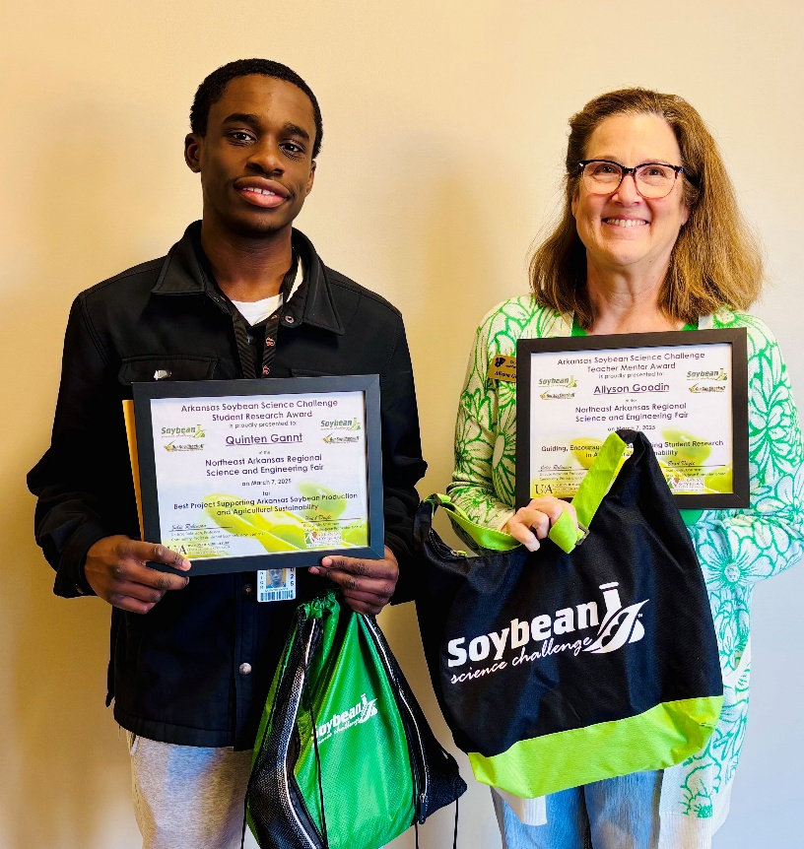

Northeast Arkansas Regional Science Fair Senior Division Winner Quentin Gantt, and Teacher-Mentor Allyson Goodin.