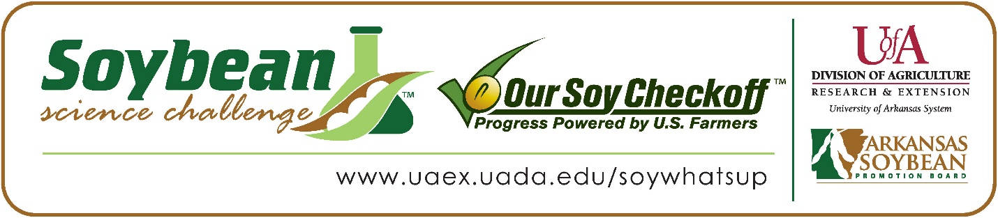

**Richard Hu wins 2025 Arkansas Soybean Science Challenge Junior Division Award at the Central Arkansas Regional Science and Engineering Fair**

Richard Hu, 12, a 6th grader at Pinnacle View Middle School, won the Soybean Science Challenge Junior Division award at the 2025 Central Arkansas Regional Science and Engineering Fair held at the University of Arkansas Little Rock on March 7. His project was titled "How does the number of soybeans harvested affect its price?”

Kristi Ward, Hu’s teacher, won the $100 Soybean Science Challenge Junior Division Teacher-Mentor Award. Ward stated the Soybean Science Challenge is a great way to get students interested in agricultural research. “I encouraged several of my students to participate in the Soybean Science Challenge because they could apply their project to a relevant topic that concerns Arkansas. If the students were passionate about soybeans and crops, they were guided to choose the topic,” she replied.

Hu was delighted to win the 2025 Junior Division Soybean Science Challenge. “I was happy, excited, and enthusiastic after winning the Soybean Science Challenge. I was thrilled, and it encourages me to do it again since my hard work paid off,” he replied.

Mr. and Mrs. Zhuopei Hu, Richard’s parents, were very happy to see him receive the award. “I was driving to UALR when my wife texted me the winning information. I saw the message on my watch and almost lost control of the vehicle. Both my wife and I were thrilled and surprised to hear that many students were conducting experiments on planting soybeans, we thought those had a higher chance of winning! We are so glad he insisted on analyzing soybean data, and we are incredibly proud of him. He spent tons of hours learning analysis methods on YouTube and checking with his science teacher, Mrs. Ward. Of course, we will continue encouraging him to explore, question, and push boundaries in science,” they stated.

Richard was impressed with what he learned from participating in the Soybean Science Challenge. “The Soybean Science Challenge online course helped me by giving me examples to include in my introduction and valuable information for my future career. For example, soybean biodiesel, being rich in protein, can help in the fight against world hunger. I also found the nitrogen fixation process and the soybean biodiesel videos interesting because both involve being environmentally friendly,” he explained.

The Soybean Science Challenge provides an opportunity for Arkansas junior high and high school students to participate in scientific research that can impact the State of Arkansas as well as the world. Soybean Science Challenge student researchers learn about this important commodity crop and its many uses including feeding the world, development of biofuels and sustainable products. The Soybean Science Challenge helps students develop an understanding of the challenges and complexities of modern farming,” said Dr. Julie Robinson, Professor, and director of the program.

“The goal of the Arkansas Soybean Science Challenge is to engage students in “real- world” education to support soybean production and agricultural sustainability,” said Gary Sitzer, a former member of the Arkansas Soybean Promotion Board. “The program also rewards scientific inquiry and discovery that supports the Arkansas Soybean Industry.”

The Arkansas Soybean Science Challenge was launched in January 2014 to 9-12th grade science students and in 2021, the SSC added grades 6-8. Students who successfully completed the online course were eligible to have their original soybean-related research projects judged at the 2025 ISEF-affiliated Arkansas Science and Engineering Fairs.

Information on the 2025-2026 Arkansas Soybean Science Challenge will be available in summer 2025. For more information, contact Dr. Julie Robinson at [jrobinson@uada.edu](mailto:jrobinson@uada.edu) or Keith Harris at [krharris@uada.edu](mailto:krharris@uada.edu) or Diedre Young at [dyoung@uada.edu](mailto:dyoung@uada.edu) .

The Cooperative Extension Service is part of the University of Arkansas System Division of Agriculture.

**Richard Hu, Pinnacle West Middle School, Little Rock, Arkansas; Teacher, Kristi Ward**

**Category: Environmental Science**

**Title: How does the number of soybeans harvested affect its price?**

**Abstract:** I wanted to know the prices of things at the grocery store, like soy sauce and tofu, which seem to increase and decline all the time. Based on what I knew about farming, and food production, I thought the amount farmers harvested could affect food costs. I hypothesized that if the number of soybeans harvested in a year were higher, then the price of soybeans would be lower, because when there is more of something available, it usually costs less (supply and demand). In my background research, I learned that many factors could affect the price of soybeans including weather, demand, transportation costs, and international trade. My experiment looked at data from the last ten years about soybean harvests and their prices. I created graphs to compare how changes in the number of soybeans harvested related to price fluctuations. Ultimately, my hypothesis was supported. In years with very large harvests, prices tended to go down. There were also exceptions where other factors, like international trade policies, made soybean prices go up despite a big harvest. While this was a challenging experiment, I realized there is a lot more to learn about how global markets and weather patterns play a role in this topic. I learned a lot about using data to explore questions and feel more confident about how science can be used to study real world problems.

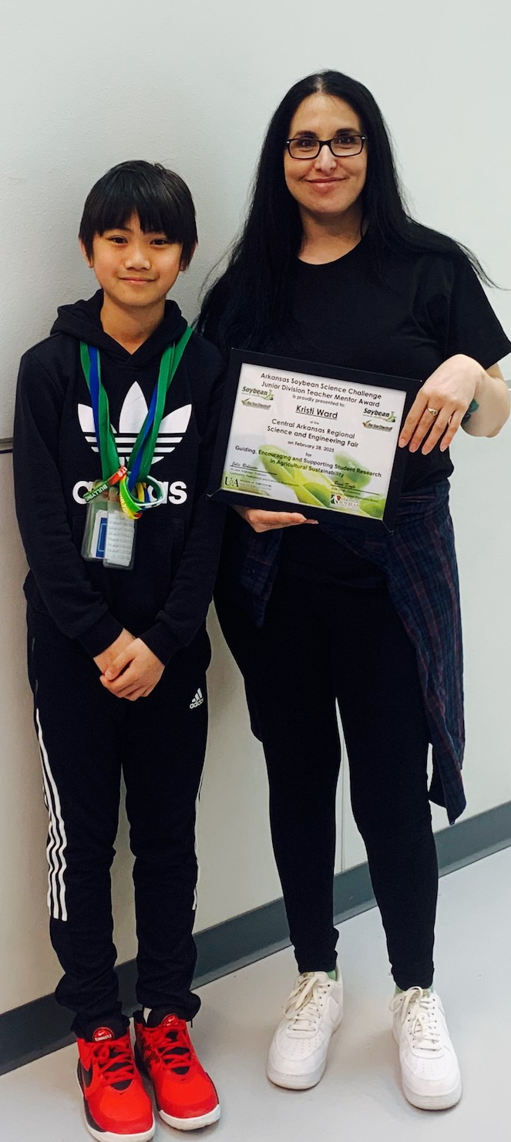

Central Arkansas Regional Science and Engineering Fair Junior Division Soybean Science Challenge winner Richard Hu and Teacher-mentor, Kristi Ward.