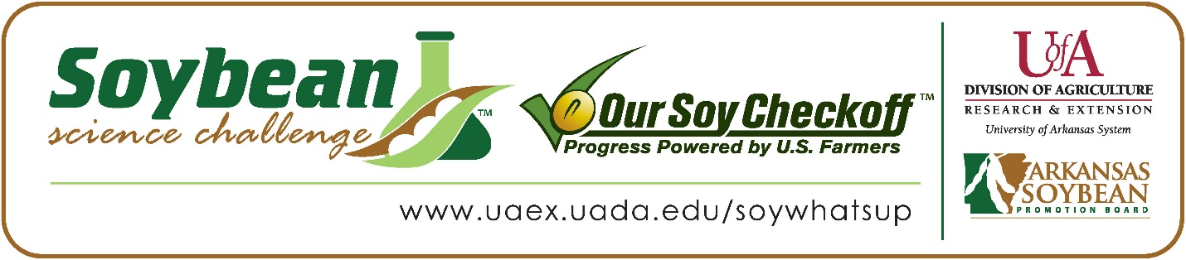

**Vishak Meenachi wins 2025 First Place Arkansas Soybean Science Challenge Award at Arkansas State Science Fair**

Vishak Meenachi, 14, a freshman at Little Rock Central High School in Little Rock, Arkansas, won the Soybean Science Challenge First Place award at the Arkansas State Science and Engineering Fair held at the University of Central Arkansas-Conway April 4.

Vishak received the $1,000 cash award for the First-Place finish at State. The award was provided by the Arkansas Soybean Promotion Board at the award ceremony. His science fair project titled “Environmental Sustainability of Soybean Derived Biodiesel compared to Standard Diesel” also took Second Place in Energy and Transportation at the Central Arkansas Regional Science and Engineering Fair, and First Place in Chemistry, plus the US Naval Science Excellence Award at the State Science Fair.

April Owen, Vishak’s teacher, won the $300 First Place Soybean Science Challenge Teacher-Mentor Award. She believes the Soybean Science Challenge is a wonderful opportunity for students to learn how to present their work. “With each level of competition, Vishak became more and more confident in presenting and defending his claim. I think he also became more aware of the importance of feedback and sharing ideas with others,” she stated.

Vishak was honored that his project was chosen to win the Soybean Science Challenge. “I am extremely honored to be the 2025 Soybean Science Challenge First Place winner. The opportunity to showcase my project on a state level is a thrilling experience and I am honored to be a part of it. Becoming the 2025 State Science winner is the most challenging, yet rewarding experience,” he replied.

Mr. Meenachi and Ms. Manickam, Vishak’s parents, were excited he won the Soybean Science Challenge Award. “We were super proud and so very excited when Vishak won the award. He had put in a lot of hard work and dedication for this project. Vishak wanted to come up with a project that provides a viable solution to a real-life problem and wanted to make a significant impact on society. He wanted to come up with an environmentally sustainable biodiesel without compromising the engine performance and comparatively lower emissions than that of standard diesel. He had been working hard to earn this recognition since middle school and this time, he made an extra effort to test this soybean derived biodiesel in a 196 cc 3.5 HP diesel engine and has plans to plug this engine in his own self designed go-kart,” they explained.

Owen talked about Vishak’s dedication “Vishak is a highly inquisitive student who excels at formulating research questions and eagerly engages in the experimental design process. He continuously reevaluates his approach and thoughtfully considers all viewpoints, demonstrating both intellectual curiosity and open-mindedness,” she stated.

Working with the Soybean Science Challenge gave Vishak a new appreciation for agriculture. “I learned about the interaction between science, technology and the utilization of Soybeans not only in the agriculture industry but also in a variety of other industries. This helped me academically understand the science behind agriculture and implement the same in the real-world scenario. I’m already more enthusiastic about exploring opportunities to decide my future career in this area,” he replied.

“The Soybean Science Challenge provides an opportunity for Arkansas high school students to participate in scientific research that can impact the State of Arkansas as well as the world. Soybean Science Challenge student researchers learn about this important commodity crop and its many uses including feeding the world, development of biofuels and sustainable products. The Soybean Science Challenge helps students develop an understanding of the challenges and complexities of modern farming,” said Dr. Julie Robinson, Professor, and director of the program.

“The goal of the Arkansas Soybean Science Challenge is to engage students in “real- world” education to support soybean production and agricultural sustainability,” said Gary Sitzer, a former member of the Arkansas Soybean Promotion Board. “The program also rewards scientific inquiry and discovery that supports the Arkansas Soybean Industry.”

The Arkansas Soybean Science Challenge was launched in January 2014 for 9-12th grade science students. Students who successfully completed the online course were eligible to have their original soybean-related research projects judged at the 2025 ISEF-affiliated Arkansas Science and Engineering fairs.

Information on the 2025-2026 Arkansas Soybean Science Challenge will be available in summer 2025. For more information, contact Dr. Julie Robinson at [jrobinson@uada.edu](mailto:jrobinson@uada.edu), Keith Harris at [kharris@uada.edu](mailto:kharris@uada.edu), or Diedre Young at [dyoung@uada.edu](mailto:dyoung@uada.edu).

The Cooperative Extension Service is part of the University of Arkansas System Division of Agriculture.

**Vishak Meenachi: Little Rock Central High School, Little Rock, Arkansas; Teacher-April Owen**

**Category: Chemistry**

**Project Title: Environmental Sustainability of Soybean derived Biodiesel compared to Standard Diesel**

**Abstract:** Biodiesel is a domestically produced renewable fuel that can be manufactured from vegetable oils, animal fats, or recycled restaurant grease for use in diesel vehicles or any equipment that operates on diesel fuel. Biodiesel, produced from renewable resources like soybean oil, has emerged as a potential substitute for standard diesel. The purpose of this project is to compare the performance and emissions of soybean derived biodiesel and standard diesel to determine if biodiesel is a viable alternative. Biofuel is produced by transesterification - a process that converts fats and oils into biodiesel and glycerol (a byproduct). After the glycerol has settled, the upper biodiesel is decanted. After the decanting, biodiesel is subjected to purification with distilled water to remove the impurities. The biodiesel is subject to vacuum filtration and is ready to be tested. A 3.5 HP diesel engine is used to test both biodiesel and standard diesel under identical testing conditions. Engine RPM is measured using a digital tachometer and the particulate matter emissions are measured using a particulate meter. From the results, it is evident that the biodiesel demonstrated higher engine performance (RPM), its emissions (PPM) were below those of standard diesel very consistently. The results align with the current research emphasizing biodiesel's potential as a renewable and a cleaner fuel option.