**2025 State Master Gardener Conference  
Garden Tours  
Friday, June 6, 2025**

**The Out of Towners Tour**

Tour a large property with flowering plants everywhere you look, a vegetable garden with amazing tomato plants and a large daylily collection.  Another tour features flawless grounds surrounding a beautiful home with numerous container gardens and landscaped beds surrounding the entire house.  Another tour features a commercial cut flower farm. The dynamo that operated this farm is a former MG. She operates an ever-expanding cut flower business and has an amazing variety of both foliage and bloom plants, many of which you have never seen.

Most walking on flat land but a little bit of distance if you want to see it all.  Distance is up to you.

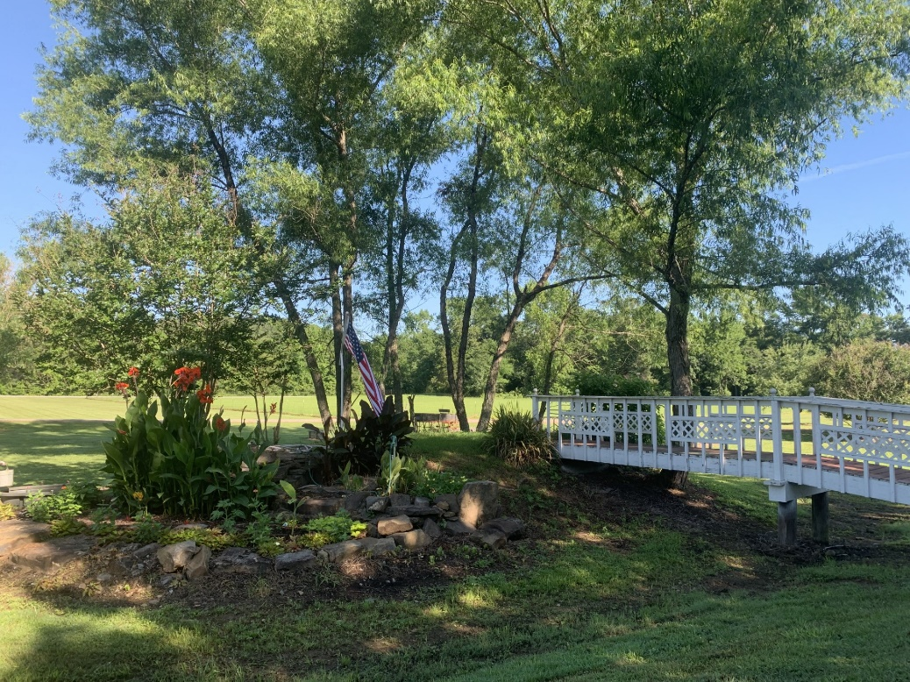

**The Berry Good Tour**

See the gardens of two of our MGs who are passionate about saving the monarch butterflies.  They have a butterfly patch, shade gardens and quality raised beds built by the homeowner. Another tour stop will feature the property of another MG having both sun and shade gardens. The beautiful large shade gardens feature hydrangeas, hellebores, ferns, and a landscaped pool area. The last stop will be at a commercial berry farm where you can see the operations of where the majority of the nations’ blackberries are grown. You will see the beautifully maintained growing fields and their picking and packaging operations.

Most walking is on flat land.

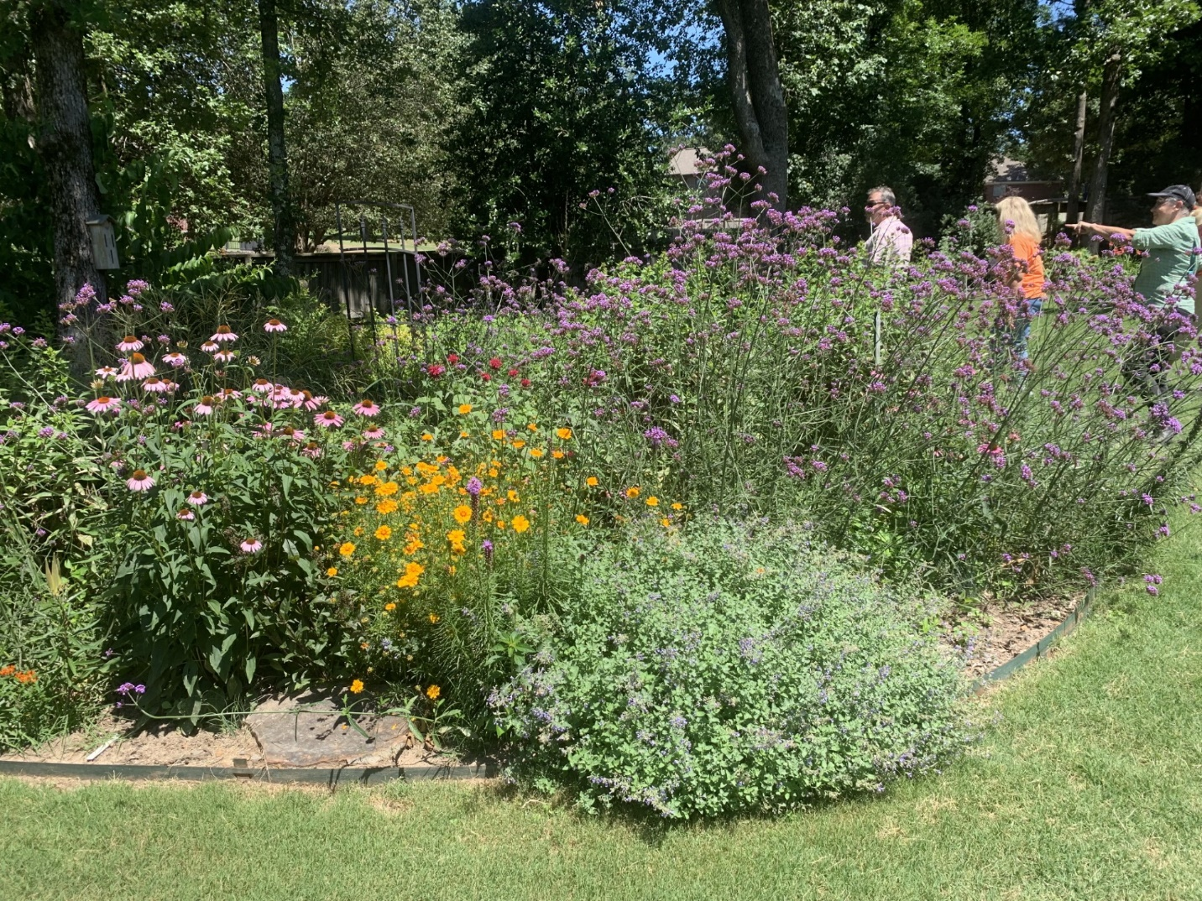

**The Backyard Beauties Tour**

See the beautiful backyard where one of our MGs has utilized every inch of the space to make gardens, storage sheds, hot tubs and pergolas. Japanese maples, azaleas, crepe myrtles and styrax trees are the star performers.  Another stop is the organic community gardens led by another of our Master Gardeners.  The purpose of these gardens is two-fold.  Of course, one purpose is to grow healthy produce, but the other is to educate new gardeners. These gardens have grown to the point there are no longer any plots available. At the home of another Master Gardener, you will see raised beds which wrap around most of the backyard.  These amazing beds are built out of large stones the husband gathered himself and used to build. An assortment of hydrangeas, roses and perennials, and heirloom raspberry patch are featured here.

Most walking is on flat land but a little bit of distance.

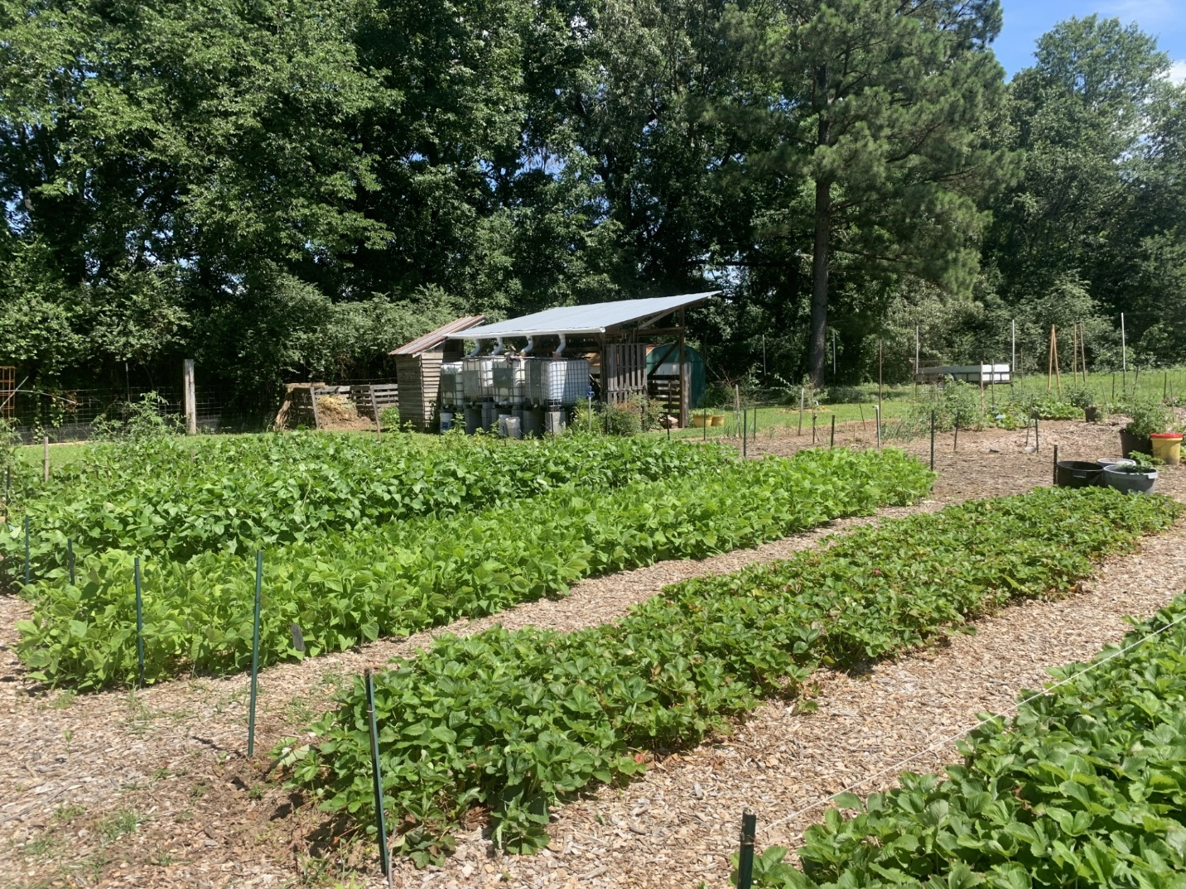

**The Pioneers Tour**

Harding University has many beautiful areas and one of the most beautiful is “The First Ladies Gardens”. Developed under the watchful eye of a former MG, this garden features hydrangeas, a wisteria arbor, and many beautiful plants and plant combinations. Another stop, Pioneer Village, was the 2024 MG State Project of the Year. A former mobile home park, it is now a coordinated effort between the Historical society and Master Gardeners. Another stop is the home of two Master Gardeners.  Their home features numerous perennials, flowering shrubs, a gazebo, and a storage building, housing antique collections of “smalls”. The final stop is a beautiful, dramatic, sharply sloping hillside garden, designed, planted and tended by the homeowner. The gardens feature a swimming pool, and multiple terraces descending the hillside.

Going all the way to the bottom and back might be strenuous but you can control how far you care to descend.

