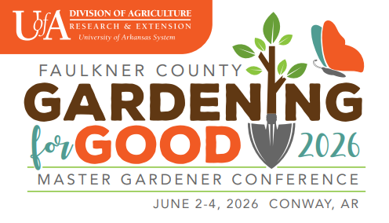
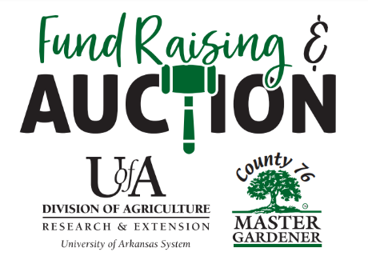
ARKANSAS
MASTER GARDENER
STATE CONFERENCE
June 2 – 4, 2026
Conway, AR

2026 POTS AND PLANTS PROJECT

An optional project that County 76 invites you to participate in is the Pots and Plants project. These unique Pots and Plants will be displayed at the 2026 Master Gardener State Conference for all to enjoy!
The Pot and Plants will be auctioned at County 76 Silent Auction.

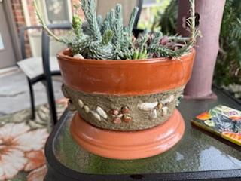
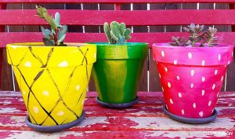
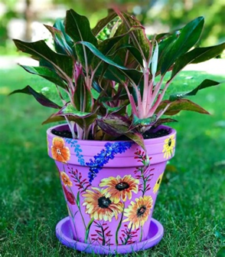
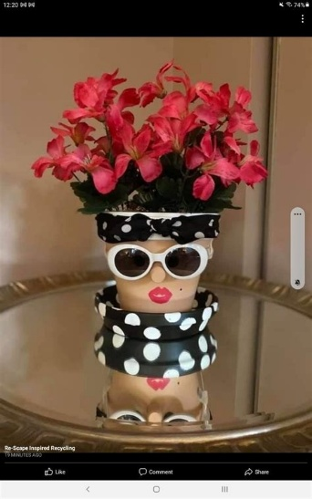
What is a Pot and Plant?

A ‘Pot and Plant’ is a handcrafted pot that reflects your personal style and contains a plant that accents the design on the pot.

Using a pot (no smaller than 4” and no larger than 8”), the pot may be painted and then decorated in any way – make a Sassy Lady or Man pot, use mosaic tiles, or just paint it with an artistic twist. It can be created individually or in a group, your choice. Be sure to include a plant with your pot.

A single pot or a group of pots can be created.
ARKANSAS
MASTER GARDENER
STATE CONFERENCE
June 2 – 4, 2026
Conway, AR

HOW DO I MAKE A POT AND PLANT?
- Supplies & Prep
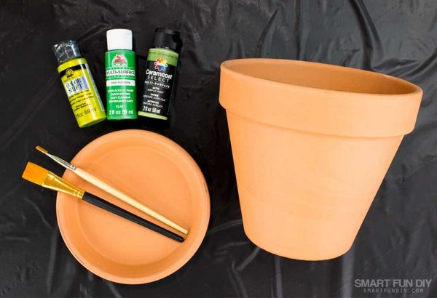
- Start with a terra cotta pot or pots – no smaller than 4” and no larger than 8”. Plastic pots may be used, but not desirable. A saucer should be included.
- Use any color outdoor or acrylic paint if you are creating a Sassy Lady or Man pot or just painting the pot.
- Use a non-yellowing waterproof sealant (Suggest: Rainguard Paint Sealer) over the pot to help seal the paint for usage inside or outside.
- Creating a mosaic, stone or other material may require a ore-coat on the pot.

- Brainstorm and Plan Your Design
- There are different examples of pots on Pinterest or Google.
- Don't copy, just get inspired! Let your spirit move you.
- Consider your color scheme and try out some sample combinations first.
- Don't forget to Sign and Date your unique pots.
- It is recommended not to actually plant the plant you selected in the pot. Leave it in the plastic pot it came in and just place it in the pot.

- Drop Off
- Deliver your Pot and Plant (or Pots and Plants) to the Silent Auction area in the Faulkner County Expo Center no later than Noon on June 2.

ARKANSAS
MASTER GARDENER
STATE CONFERENCE
June 2 – 4, 2026
Conway, AR

WHAT IF I NEED HELP?
- Reach out to the County 76 Fundraising Project. The chair and co-chair would be glad to speak or Zoom with you to answer questions. Contact either Susan Colles at 479-857-8544 or scolles53@yahoo.com or Sheila Waddell at (870-489-9768) or Sheilahs1@yahoo.com for assistance.

PARTICIPATION DEADLINE
- Please confirm your participation in creating Pots and Plants by March 15. 2026 by completing the application at the following link: https://uada.formstack.com/forms/pots_plants

